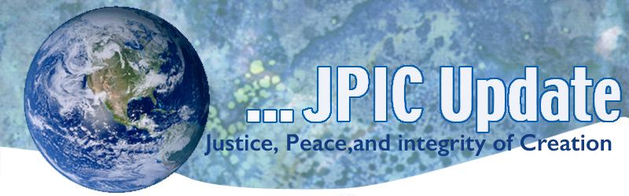
July 1, 2019
Preamble to the Constitution of the United States
We the people of the United States, in order to form a more perfect union, establish justice, insure domestic tranquility, provide for the common defense, promote the general welfare, and secure the blessings of liberty to ourselves and our posterity, do ordain and establish this Constitution for the United States of America.

July
July 4 Independence Day
July 9 Independence Day for South Sudan
July 14 St. Kateri Tekakwitha
July 18 Nelson Mandela Day

*****************
TAKING ACTION
Be a voice for the voiceless
*********************
Take time to access this tool
CLINIC (Catholic Legal Immigration Network) has developed an excellent resource for use by immigrants, those accompanying them, and all who want to stand against this administration’s immoral policies and practices.

The newly released toolkit is based on best practices and lessons learned from communities conducting rapid responses during ICE raids and arrests. It provides a plan of action for communities to support and guide people during and after a raid, as well as a how-to guide and a model notebook to help you build an inclusive rapid response team. It will help your local community organize and stay informed.
Support Renewable Electricity Standard
The good news is that Senator Tom Udall of New Mexico just announced the Renewable Electricity Standard (RES) Act of 2019, which lays out a plan that will put the United States on track for 50 percent renewable electricity nationwide by 2035. The bill would steadily increase states' use of renewable sources, such as wind and solar, and is designed to ensure that every state makes advances in clean, renewable sources of electricity.
Write today and urge your senators to support the robust growth of clean energy deployment across our country by cosponsoring the RES Act of 2019.

Raise the Minimum Wage
This month marked a shameful milestone in our nation. On June 16, we entered the longest period in U.S. history without an increase in the federal minimum wage. It has been a decade since Congress last increased the minimum wage to $7.25 an hour. Stagnant wages and inflation mean the federal minimum wage is now worth 17% less than it did 10 years ago.
EMAIL YOUR REPRESENTATIVE TODAY
Tell Them to Pass the Raise the Wage Act without Any Harmful Amendments
It is morally reprehensible that millions of people work full time, yet are a paycheck away from acute poverty and homelessness. Full time work should earn enough to keep families out of poverty.
***************************
INFORMATION/RESOURCES
***************************
Iran and the U.S.
The U.S. and Iran have had turbulent relations since 1979, but the temperature has risen since Washington withdrew from the Iran nuclear deal. Hostilities escalated recently with attacks on foreign tankers and a U.S. drone. USIP’s Robin Wright discusses where the crisis stands, and where it could turn.
Read the analysis
China’s role in the North Korea peace process
We know that it’s hard to stay up to date on USIP’s latest research, so we’ve challenged our teams to summarize their latest publications in less than a minute. In this edition, USIP’s Frank Aum explains why Beijing is crucial to nuclear diplomacy with Pyongyang and how the U.S. and China can work together
Watch now
Every Voice Counts!
Trader Joe’s phasing out single-use plastics nationwide following customer petitions https://www.ecowatch.com/trader-joes-plastic-waste-2630818452.html

Climate change could bring a new kind of apartheid
Extreme weather driven by climate change is increasing the risk of a new kind of apartheid in the world, where the wealthy pay to escape its effects and the poor are forced to migrate or starve, warns Philip Alston, United Nations special rapporteur on extreme poverty and human rights. Alston warns that a warming planet will affect basic human rights as well as civil rights, democracy and the rule of law.

Statements and Actions from USCCB Department of Justice, Peace and Human Development
- Following the lead of Pope Francis, the full body of U.S. Bishops approves revised teaching on the death penalty in U.S. Catechism for Adults.
- Chairman of the Committee on International Justice and Peace voices hope that U.S. will de-escalate Iran conflict.
- Chairman of the U.S. Bishops’ Committee on International Justice and Peace share support for Church in Burkina Faso following multiple terrorist attacks.
- Chairman of the U.S. Bishops’ Committee on International Justice and Peace expresses concern about strengthening of embargo against Cuba.
- Chairman of the U.S. Bishops’ Committee on Domestic Justice and Human Development responds to horrific violence, in wake of shooting in Virginia Beach.
- Chairman of U.S. Bishops’ Committee on Migration welcomes passage of House Resolution 6, giving protection to Dreamers and TPS holders while urging passage in Senate.
- Chairman of U.S. Bishops’ Committee on Migration shows solidarity and support for brother bishops in Mexico and for migrants at the U.S. southern border.
- Chairman of U.S. Bishops’ Committee on Migration expresses concern and solidarity for families impacted by imminent deportation plans.

