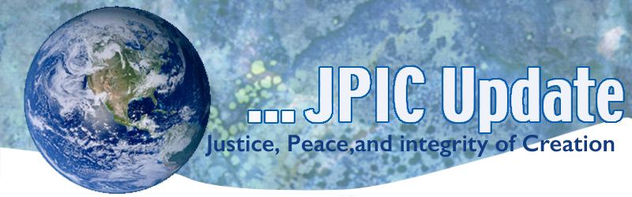
July 15, 2019
"If you think you are too small to make a difference just think of sleeping with a mosquito in the room." —Tenzin Gyatzo, 14th Dalai Lama

July
July 18 Day of Action for Immigrants
July 18 Nelson Mandela Day
July 30 World Day against Trafficking in Persons
August
August 6 74th Anniversary of bombing of Hiroshima
August 9 74th Anniversary of bombing of Nagasaki

*****************
TAKING ACTION
Be a voice for the voiceless
*********************
Act NOW! (from the Justice Conference of Women Religious)
Call the White House and let your voice join the chorus of Catholics who say no more to tearing families and communities apart and say yes to welcome and love.
Earlier this week, Pope Francis urged Catholics around the world to stand with migrants and against an attitude of indifference and despair. He said, “Migrants are persons… They are the symbol of all those rejected by today’s globalized society… The weakest and most vulnerable must be helped… This is a tremendous responsibility, from which no one is exempt if we wish to fulfill the mission of salvation and liberation, in which the Lord himself has called us to cooperate.”
Call the White House Now! Call (202) 456-1111

Suggested Script
As a person of faith, I am calling today to strongly oppose the Trump Administration’s efforts to hold children in dangerous detention centers, and separate immigrant families at the border and in communities around the country. Family is sacred—it is the cornerstone of our church and our community and must be protected. The Administration’s policies have led to the tragic deaths of seven children and are traumatizing a whole generation of children.
Guided by our Catholic faith and our national values, we affirm the dignity of all people and our call to love our neighbors. Every person, every family deserves stability and security.
We call on the Trump Administration to immediately end the unjust and immoral practice of jailing children and separating families.

***************************
INFORMATION/RESOURCES
***************************
Good News from Catholic Charities USA
Prior to leaving Washington, Congress passed a $4.6 billion border supplemental spending package aimed at providing humanitarian aid at the border. The funds provided $793 million for Customs and Border Protection migrant care and processing facilities, $112 million for medical and supplies such as clothing and hygiene products, and $30 million for local nonprofits to deal with the crisis through the Emergency Food and Shelter Program. This week Congress continued to shine a spotlight on the crisis at the border with hearings regarding the administration's child separation policy.

How we are Honoring People Overlooked by History (TED Talk)
Since its founding in 1851, the New York Times has published thousands of obituaries -- for heads of state, famous celebrities, even the inventor of the sock puppet. But only a small percentage of them chronicle the lives of women and people of color. In this insightful talk, Times editor Amy Padnani shares the story behind "Overlooked," the project she's leading to recognize people from history whose deaths were ignored -- and refocus society's lens on who is considered important.
Watch now »

From Catholic Climate Covenant
I am so pleased to share with you that on July 10 we announced the largest ground-based solar array ever developed in Washington, DC. This project was managed by our Catholic Energies team and benefits Catholic Charities in the Archdiocese of Washington.
Attached is a press release announcing this 2 megawatt project in the District of Columbia for the benefit of Catholic Charities, Archdiocese of Washington. You can also visit https://www.catholicenergies.org/ccadw-announcement to learn more.
From UN Wire
- UN urges Libya cease-fire as trapped migrants go on hunger strike France 24
- New UNESCO listings include cities, forests, sanctuaries The Guardian (London)
- UNODC report: Domestic violence fatalities rising The Brussels Times online (Belgium)
- Monsoon rains bring destruction to Rohingya camps in Bangladesh Voice of America

