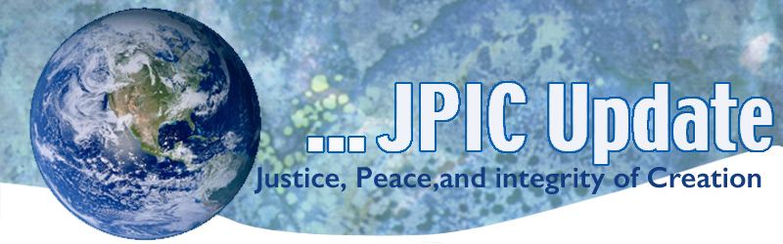
July 8, 2019

"Inside the word emergency is emerge; from an emergency new things come forth. The old certainties are crumbling fast, but danger and possibility are sisters." -Rebecca Solnit

July
July 9 Independence Day for South Sudan
July 11 World Population Day
July 14 St. Kateri Tekakwitha
July 18 Nelson Mandela Day
July 30 World Day against Trafficking in Persons
August
August 6 74th Anniversary of bombing of Hiroshima
August 9 74th Anniversary of bombing of Nagasaki

*****************
TAKING ACTION
Be a voice for the voiceless
*********************

Catholic Leaders Call for the Safety and Security of Asylum Seekers
The United States Conference of Catholic Bishops and Jesuit Refugee Service/USA released statements calling for the safety, security, and dignity of asylum seekers after reports of deaths on the U.S.-Mexico border and appalling child detention conditions.
Join these voices through ISN's Light in the Darkness campaign

How to Deconstruct Racism
Baratunde Thurston explores the phenomenon of white Americans calling the police on black Americans who have committed the crimes of ... eating, walking or generally "living while black." In this profound, thought-provoking and often hilarious talk, he reveals the power of language to change stories of trauma into stories of healing -- while challenging us all to level up.
How to deconstruct racism, one headline at a time
What challenge/opportunity does this Ted Talk pose for me/us to level up?

***************************
INFORMATION/RESOURCES
***************************
The Philippines Now Requires Students to Plant 10 Trees In Order To Graduate
In an effort to combat global warming, one small island nation is enlisting its students to exercise their green thumbs and leave behind a living legacy for future generations. The Philippines recently passed a new bill, the "Graduation Legacy For the Environment Act, which requires all “elementary, high school, and college students to plant at least 10 trees each as a prerequisite for graduation,” officials announced. Read more: https://www.good.is/articles/philippines-trees-graduation?utm_source=thedailygood&utm_medium=email&utm_campaign=dailygood

UNESCO pushes education as migrant resettlement needs rise
Educating today's children about the horrors of displacement and the journey of refugees could eliminate the misunderstanding refugees face from potential host communities, according to a report by UNESCO. The United Nations High Commissioner for Refugees says more than 1.4 million refugees will need to be resettled in 2020, and is urging countries to open their doors to displaced people.

UN report calls on Venezuela to end human rights violations
The Office of the High Commissioner for Human Rights has issued a report urging Venezuela to cease and resolve the government's "grave violations" of various rights. The report states that the Venezuelan government is responsible for imprisoning political opponents, extrajudicial killings, torture and more.

