LITANY OF
KATERI TEKAKWITHA

Gah-deh-lee Deh-gah-quee-tah

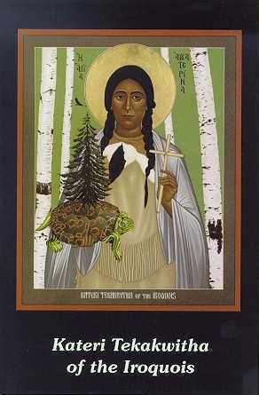
Lord, have mercy on us.
Christ, have mercy on us.
Lord, have mercy on us.
Christ, hear us.
Christ, graciously hear us.
God the Father of Heaven, have mercy on us.
God the Son, Redeemer of the World have mercy on us.
God the HolySpirit, have mercy on us.
Holy Trinity, one God, have mercy on us.

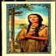
Kateri, lily of purity, pray for us.
Kateri, consoler of the heart of Jesus, pray for us.
Kateri, bright light for all Indians, pray for us.
Kateri, courage of the afflicted, pray for us.
Kateri, lover of the cross of Jesus, pray for us.
Kateri, flower of fortitude for the persecuted, pray for us.
Kateri, unshakeable in temptations, pray for us.
Kateri, full of patience in suffering, pray for us.
Kateri, keeper of your virginity in persecutions, pray for us.
Kateri, leader of many Indians to the true faith through your love for Mary, pray for us.
Kateri, who loved Jesus in the Blessed Sacrament, pray for us.
Kateri, lover of penance, pray for us.
Kateri, who traveled many miles to learn the faith, pray for us.
Kateri, steadfast in all prayer, pray for us.
Kateri, who loved to pray the rosary for all people, pray for us.
Kateri, example to your people in all virtues, pray for us.
Kateri, humble servant to the sick, pray for us.
Kateri, who by your love of humility, gave joy to the angels,
pray for us.
Kateri, your holy death gave strength to all Indians
to love Jesus and Mary, pray for us.
Kateri, whose scarred face in life became beautiful after death,
pray for us.
Lamb of God, who takes away the sins of the world, spare us, 0 Lord.
Lamb of God, who takes away the sins of the world, graciously hear us, 0 Lord.
Lamb of God, who takes away the sins of the world, have mercy on us.

LET US PRAY

0 Jesus, who gave Kateri to the Indians as an example of purity, teach all men to love purity, and to console your immaculate Mother Mary through the lily, Kateri Tekakwitha, and your Holy Cross, Amen.

Kateri Tekakwitha, pray for us.

