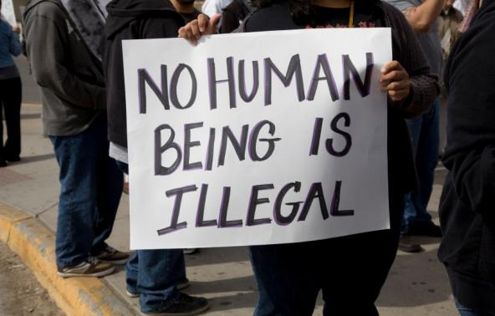
Prayer for Immigrants and Refugees
Lord Jesus, when you multiplied the loaves and fishes, you provided more than food for the body, you offered us the gift of yourself, the gift which satisfies every hunger and quenches every thirst! Your disciples were filled with fear and doubt, but you poured out your love and compassion on the migrant crowd, welcoming them as brothers and sisters.
Lord Jesus, today you call us to welcome the members of God's family who come to our land to escape oppression, poverty, persecution, violence, and war. Like your disciples, we too are filled with fear and doubt and even suspicion. We build barriers in our hearts and in our minds.
Lord Jesus, help us by your grace,
- To banish fear from our hearts, that we may embrace each of your children as our own brother and sister;
- To welcome migrants and refugees with joy and generosity, while responding to their many needs;
- To realize that you call all people to your holy mountain to learn the ways of peace and justice;
- To share of our abundance as you spread a banquet before us;
- To give witness to your love for all people, as we celebrate the many gifts they bring.
We praise you and give you thanks for the family you have called together from so many people. We see in this human family a reflection of the divine unity of the one Most Holy Trinity in whom we make our prayer: Father, Son, and Holy Spirit. Amen.

