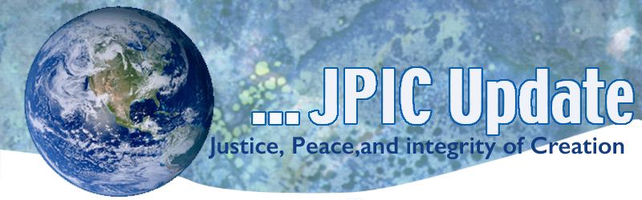
August 19, 2019

"What does it mean to be loving? How can I be loving? It so often comes down to such simple things as, 'Can I value you? Can I be courteous to you? Can I honor you? Can I treat you with integrity?' We think of love as an attitude and at times struggle to have it, but in many ways it is a behavior. It is what we do."
—David Spangler, The Call

August
August 19 World Humanitarian Day
August 26 Women’s Equality Day
August 23 International Day for the Remembrance of the slave trade and it Abolition
August 25 Ring Bells for Healing
August 29 International Day against Nuclear Tests
September
Sept.1-Oct 4 Season of Creation
Sept. 14-22 Nonviolent Week of Action
Sept 20 Week of Climate Strike

*****************
TAKING ACTION
Be a voice for the voiceless
*********************
Immigrant Children in Detention
Reports from the border are heartbreaking: children unable to brush their teeth, bathe or change their clothes for weeks at U.S. Customs and Border Protection facilities. Organizations like Amnesty International USA have not gotten access to monitor conditions in the facilities, even though the need to shine a light on them is more urgent than ever.

We cannot sit idly by and let this crisis unfold without sending our research team to investigate.
TAKE ACTION

Free the Vote
Our democracy is strong when it is fair and inclusive. But California's Constitution denies nearly 50,000 people the right to vote simply because they're on parole. This system is racist — three out of four Californians on parole are people of color — and this exclusion silences the voices of Black and brown communities.
Everyone deserves to have their right to vote.
Tell your state assembly member to vote YES on ACA 6.

August 25 Ring Bells for Healing
On behalf of the Pax Chisti Anti-Racism Team, we are joining with the members of the Episcopal Church on August 25 to participate in a Healing Day of National Bell Ringing. (Link to details - here.)

We are inviting you to contact your local Catholic parish asking them to toll their church bells at 3 p.m. on Sunday, Aug. 25, 2019, to commemorate the 400 years of African History and Culture in the US and to continue (or begin) the work of racial healing.

***************************
INFORMATION/RESOURCES
***************************
Good News for Immigrant Children
U.S. Court of Appeals, San Francisco sides with kids—upholds protections in Flores Agreement that sets national policy for the detention, release and treatment of minors in the custody of the Immigration and Naturalization Service. The government must implement standards relating to the care and treatment of children in immigration detention.

Make roads from plastic bags and glass.
Sixteen miles north of Melbourne, there is a road paved with the equivalent of 200,000 plastic bags, 63,000 glass bottles and waste toner from 4,500 printer cartridges. It is the first road in the world made of Reconophalt, a combination of recycled materials and asphalt.
The new material is “a dumping ground for plastics,” said Peter Tamblyn, a spokesman for Close the Loop, the company that developed the material.
So far, hundreds of miles of roads using Reconophalt have been laid around Australia, and trials are taking place in the United States and Britain.

A Green Approach to Gun Control
"Tajinder Singh, 47, a farmer in the North Indian state of Punjab, applied for a gun license. He told the authorities that he needed a revolver for self-defense. While tending to his 20 acres of land, he often had to walk long hours to reach home after nightfall. He wanted to protect himself from wild animals and bands of armed robbers. Once the background checks were completed in June this year, Singh was told he had to fulfill one more condition to get his gun. He had to submit two photos: One showing him planting 10 saplings on his property, and then another with the thriving trees one month later."

More than 500 Central American migrants have died this year
Migrant deaths in the Americas have already reached 500 this year -- a 33% increase over last year, according to the International Organization for Migration. A World Food Programme spokesperson says the majority of the region's migration is driven by hunger as crops fail due to climate change.

Panel to consider additional protections for endangered wildlife
A committee of experts for the United Nations Convention on International Trade in Endangered Species of Wild Fauna and Flora will begin meeting Saturday to consider enhanced protections for endangered plants and animals. The panel will hear requests from countries to increase protections for a variety of species, including giraffes, otters and a number of types of fish.

What’s Next with North Korea?
On June 30, President Trump and Kim Jong Un agreed to resume working-level talks, but they have yet to start and North Korea has since conducted several missile tests. USIP’s Frank Aum and Ambassador Joseph Yun look at what these tests mean and the prospects for progress in the rest of 2019.

Read the Q&A

Global Climate Strike
Global Climate Strike is an international movement of school students who are deciding not to attend classes and instead take part in demonstrations to demand action to prevent further global warming and climate change. Publicity and widespread organizing began when the climate activist Greta Thunberg staged an action in August 2018 outside the Swedish parliament, holding a sign that read "Skolstrejk för klimatet" ("School strike for the climate").
-Adapted from Wikipedia

