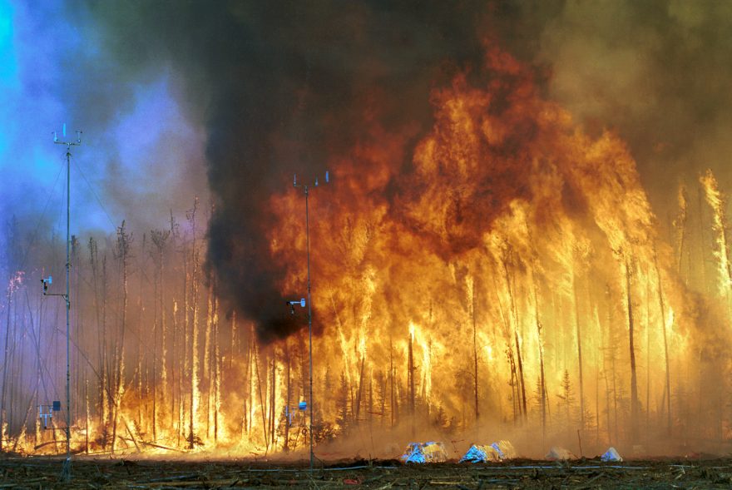

Dear Lord, we come before you with a heavy heart,
as we know Your heart must be heavy,
grieving for the loss of precious life
in the Amazon.

We pray that in Your mercy You will forgive
our ways of life, for we have created the markets
for beef, lumber, and minerals
taken from the Amazon. We pray that You will forgive

those who set fires in the Amazon,
those who cut down the ancient trees,
those who plunder the waters
to fulfill our hunger.

Our God, Your mercy is infinite
and Your power to redeem is untold.
Grant us Your grace as we turn to new ways of life,
and send your love like a balm

to heal the scorched earth and its people.
In the precious name of Your son, Jesus, we pray.
Amen.
(prayer from Global Catholic Climate Movement)

