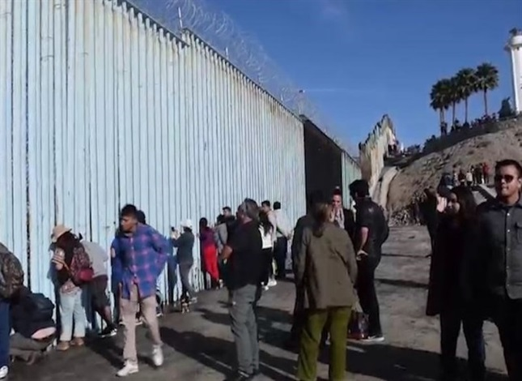

A Prayer for Migrants at the US/Mexico Border

An Encounter with Silence
Loving God,
I come before you to pray for my brothers and sisters,
your children and members of Christ’s body,
at the southern border of the United States today.
What we read of their suffering
seems nothing less than a Passion for thousands.
Little children crowded into cells
where they scarcely have room to stand.
Without decent sanitation or food,
separated from their families,
the older ones taking care of the younger.
God of mercy,
I believe that you live within whatever and whoever I am,
the ground of my existence, its gracious cause and hope,
its true future, its blessed promise of eternal life.
I could not always have said so much.
But now through your grace I do believe it.
But God of all,
I am shaken in that faith
when I read of what is happening on the threshold of my country.
Are not the women and men and children there also vessels of your eternal presence?
Many of them, most perhaps, from what we call the Northern Triangle,
have indeed been baptized.
But your incarnate Word is addressed to all of them.
Your Spirit of freedom hovers over all of them.
Who will speak your Word and give your Spirit to them now?
How will the freedom and responsibility,
the integrity and compassion Christ came to secure for us all
come now to our country and its leaders
in this time of squalor and rejection,
if those are even words strong enough for what is happening?
Can I continue to believe
that you are more interior to my soul than I am to myself
without confessing the same truth for every soul
on the border in Arizona and New Mexico and Texas?
Oh, gracious God,
you are silent.
But give us, I beg, the words and wisdom,
the courage and yes also the tact,
not to speak empty words about your presence
while others of your children,
your children and ours,
are suffering what seems worse than death.
Prayer by Leo J. O’Donovan, SJ

