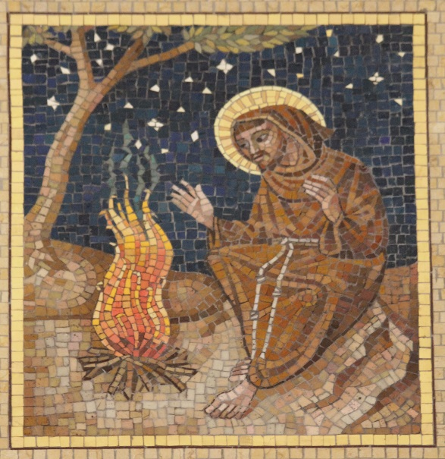

Canticle of the Creatures
St, Francis of Assisi

Praised be you, my Lord, with all your creatures,
especially Sir Brother Sun,
who is the day and through whom you give us light.
And he is beautiful and radiant with great splendor;
and bears a likeness of you, Most High.

Praised be you, my Lord, through Sister Moon and the stars, in heaven you formed them clear and precious and beautiful.

Praised be you, my Lord, through Brother Wind,
and through the air, cloudy and serene, and every kind of weather through whom you give sustenance to your creatures.

Praised be you, my Lord, through Sister Water,
who is very useful and humble and precious and chaste.

Praised be you, my Lord, through Brother Fire,
through whom you light the night,
and he is beautiful and playful and robust and strong.

