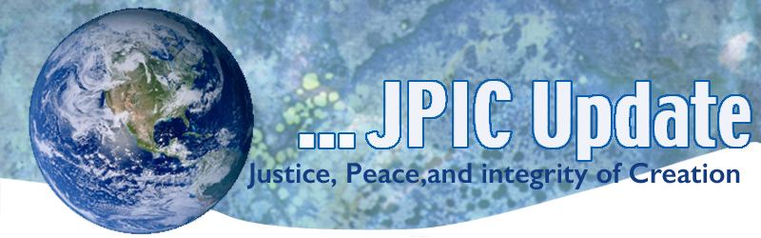
September 23, 2019
"Never think that war, no matter how necessary, nor how justified, is not a crime."
—Ernest Hemingway

September
Sept. 23-29 Climate Week
Sept. 25 World Day of Immigrants and Refugees
Sept. 26 World Environmental Health Day
Sept. 28 Anniversary of Martin Luther King. Jr’s I have a Dream speech
Sept. 29 Rosh Hashanah begins at sunset
October
October is Respect Life Month
Oct. 4 Feast of St. Francis

*****************
TAKING ACTION
Be a voice for the voiceless
*********************
Climate Week-Take the Climate Test
https://www.nbcnews.com/news/specials/climate-confessions-share-solutions-climate-change-n1054791

World Day of Migrants and Refugees
Join your community in marking World Day for Migrants and Refugees on September 25th. Resource kits are available from both Justice for Immigrants and the Vatican. In addition, you can show that you stand in solidarity with immigrants and take needed action by contacting your representatives about important changes to U.S. immigration policy.

Take action to stop Trump Admin’s H-2A proposal which could slash wages for both US & foreign farm workers
The Trump Administration's Department of Labor just posted harmful regulatory changes in the Federal Register that would drastically reduce wages and job opportunities for US workers and protections for workers on H-2A visas. The 489 pages of complex regulations announced by the Trump Administration would devastate protections for all farm workers and we must keep them from rolling out. The public comment period has just opened and will be open until September 24. Please help us do all we can to make sure these changed regulations do not go in effect by taking action today.

Raise Your Voice for Refugee Resettlement
This is a critical moment for refugees and for the United States. President Trump has until September 30 to decide the number of refugees to be admitted to the United States for Fiscal Year (FY) 2020. Some individuals in the Trump Administration are reportedly calling for "zeroing out" the refugee resettlement program. This would mean setting the goal for the number of refugees admitted into the United States in 2020 to zero.
Take Action: Raise your voice now for refugees and resettlement
Click here to send a letter to President Trump and Congress.

*****************************************
INFORMATION/RESOURCES/REFLECTION
*****************************************
Season of Creation: Third Week
To see the Universe through the lives of love helps make sense of evolution, not as a process of cold, blind chance or randomness, but one of passion, yearning, union, gift, suffering, death and new life. Love is the faithful heart of the cosmos, the consistency of all life, yet love seeks to become more being-in-love and hence the energy of change.

The name of ‘God’ points to this mystery of love in its unlimited depths, the center of all that is, love that overflows onto new life. Every star, every galaxy, every leaf and bird breathed forth in divine love.

We can read the history of our 13.7 billion year old universe as the rising of Divine Love incarnate, revealing love’s urge towards wholeness through reconciliation, mercy peace and forgiveness.
(This is adapted from a reflection by Sr. Ilia Delio, a Franciscan Sister and scientist)

A video worth watching and pondering from Sojourners
After viewing the video below you may asked yourself: What are my politics?
anti-Christ politics vs. the politics of Jesus

How Climate Change could make food less nutritious
Rising carbon levels in the atmosphere can make plants grow faster, but there's another hidden consequence: they rob plants of the nutrients and vitamins we need to survive. In a talk about global food security, epidemiologist Kristie Ebi explores the potentially massive health consequences of this growing nutrition crisis -- and explores the steps we can take to ensure all people have access to safe, healthy food.
Watch now »

UN chief urges people to pressure leaders for climate action
The world is "losing the race" against climate change, and all of society must put pressure on lawmakers to take concrete action toward reaching climate goals, United Nations Secretary-General Antonio Guterres said this week. The global community must make "profound changes in the way we produce food, in the way we power our economies, in the way we organize our cities, in the way we produce energy" to avert disaster, he warned.

In the News from Peace Justice and Human Development Office USCCB
- President of U.S. Bishops’ Conference and Chairmen of Committees on International Justice and Peace, and Domestic Justice and Human Development call for “spiritual and corporal works of mercy towards our common home” in response to the Amazonian fires.
- President of U.S. Bishops’ Conference calls on Catholics to pray and support relief efforts of CRS following deadly Hurricane Dorian.
- Chairman of U.S. Bishops’ Committee on Domestic Justice and Human Development issued the annual Labor Day statement calling attention to present economic difficulties in our country.
- Chairman of the U.S. Bishops’ Committee on Migration strongly opposes new rules which will undermine protections in place for immigrant children
A Free World Needs Political Cartoons
We need humor like we need the air we breathe, says editorial cartoonist Patrick Chappatte. In a talk illustrated with highlights from a career spent skewering everything from dictators and ideologues to selfies and social media mobs, Chappatte makes a resounding, often hilarious case for the necessity of satire. "Political cartoons were born with democracy, and they are challenged when freedom is," he says.
Watch now »

