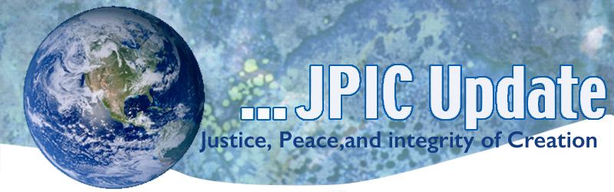September 30, 2019
"I have never met any human being in all my travels—and I have traveled extensively, including time spent with Native American peoples, with Australian Aborigines, and with the Maoris of New Zealand—that gave me the slightest doubt that in our heart of hearts we are all one. Not just similar—one; there is only one human heart."
—David Steindl-Rast, Timeless Visions, Healing Voices

October
October is Respect Life Month
Oct. 2 International Day of Non-violence
Oct. 2 Birthday of Mohandas Gandhi (1869-1948)
Oct. 4 Feast of St. Francis
Oct. 5 World Teacher’s Day
Oct. 7 World Habitat Day
Oct. 11 International Day of the Girl Child
Oct. 12 Columbus Day/Indigenous Peoples Day
Oct. 16 World food Day

*****************
TAKING ACTION
Be a voice for the voiceless
********************
October is Respect Life Month!
As Catholics, we believe that every life is sacred, from the moment of conception until natural death. Click on the following, view the short video, and access the available resources.

Respect Life Month | CRS

Support No Funds for Public Charge Bill
The Administration has finalized a dangerous and unnecessary expansion of the definition of “public charge” when determining the eligibility of legal immigrants to apply for lawful permanent residency (LPR). Under the final rule, enrollment in the Medicaid program could prevent legal immigrants from attaining LPR, and force many to choose between vital health care coverage and the ability to adjust immigration status. CHA is supporting legislation to deny any federal funds from implementing the Public Charge rule, and urges you to write your members of Congress in support of the bill.
TAKE ACTION
Speak Up and Tell the USDA to Protect SNAP Recipients
The USDA proposed a rule that limits the application of categorical eligibility for SNAP, essentially revising the income and asset limits for SNAP eligibility. These changes would make the SNAP program less efficient, discourage personal savings, undermine the ability of states to respond to local needs, and cause 3.1 million people to lose needed nutrition assistance. Congress already has considered and rejected similar changes twice, during debate on the 2014 Farm Bill and the Agriculture Improvement Act of 2018.

Take Action

The United States must lead on climate action
Three days ago, Pope Francis delivered a video message during the opening plenary of the United Nations General Assembly in which he stated:

"While the situation is not good and the planet is suffering, the window of opportunity is still open. Despite everything. Let us not let it close. Let us open it with our determination to cultivate integral human development, to ensure a better life for future generations."

The time to take action is NOW. The United States must lead on climate action and the US Senate must ensure that we participate in international agreements which seek to prevent the impacts from climate change from doing irreparable harm to our common home and our shared future.
SIGN THE PETITION

******************************************
INFORMATION/RESOURCES/REFLECTION
******************************************
Feast of St. Francis - Fourth and last Day in the Season of Creation
October fourth is the feast of St. Francis, a day in which animals are traditionally blessed. St. Francis praised God for all creatures and had a unique relationship with animals.

In Laudato Si’, paragraph 86, Pope Francis states, “We understand better the importance and meaning of each creature if we contemplate it within the entirety of God’s plan. As the Catechism teaches: “God wills the interdependence of creatures. The sun and the moon, the cedar and the little flower, the eagle and the sparrow: the spectacle of their countless diversities and inequalities tells us that no creature is self-sufficient. Creatures exist only in dependence on each other, to complete each other, in the service of each other”.
Animals have a special place and relationship with humans. There are those that provide service and support. The majority of people enjoy the companionship, love, faithfulness and joy that an animal brings.
The Governor of California’s first pet was an Otter! What was your first pet?
Building a wall will not solve the border problem
"Building a 30-foot-high concrete structure from sea to shining sea is the most expensive and least effective way to do border security," says Congressman Will Hurd, a Republican from Texas whose district encompasses two times zones and shares an 820-mile border with Mexico. Speaking from Washington, DC in a video interview with former state attorney general Anne Milgram, Hurd discusses the US government's border policy and its controversial detention and child separation practices -- and lays out steps toward a better future at the border. (Recorded at the TED World Theater in New York on September 10, 2019)
Watch now »

Voice for the Planet
From disappearing species to plastic pollution and our disastrously weak attempts to recycle it, here's what the top voices on climate change - from Sir David Attenborough to Jane Goodall to Greta Thunberg - have to say about the planet's escalating biodiversity crisis click on the following to watch the video and to read more- { read more }
Ask yourself: “How does my action/decision affect the earth community?”

UN chief urges global cooperation as Trump espouses nationalism
Global leaders must embrace multilateralism and international cooperation to avoid the threat of a world split in two as China and the US push their own internets, trade, financial rules and military strategy, United Nations Secretary-General Antonio Guterres warned this week in his address on the state of the world. US President Donald Trump addressed the UN General Assembly with a speech that touted the benefits of nationalism, saying "the future does not belong to globalists."

California-China Climate Institute
On Monday, Jerry Brown, the former governor of California, announced that he’s starting an institute at U.C. Berkeley aimed at tackling the climate crisis with help from what he described as a critical ally: China.

The California-China Climate Institute is intended to help spur partnerships between various state agencies and policymakers in China, as well as researchers at Tsinghua University.

Envoy lauds formation of Syrian constitutional committee
The formation of a committee to develop a new constitution for Syria has opened the doors to future elections supervised by the United Nations, says UN envoy for Syria Geir Pedersen. UN Secretary-General Antonio Guterres this week announced an agreement to form the committee, which will be composed of 50 members selected by the Syrian government, 50 chosen by the opposition and 50 selected by the UN.

Some other thoughts worth pondering:
“Right here, right now is where we draw the line. The world is waking up. And change is coming, whether you like it or not.”
-Greta Thornburg

"The world is a dangerous place, not because of those who do evil, but because of those who look on and do nothing."
—Albert Einstein

"In the end, we will remember not the words of our enemies but the silence of our friends."
—Dr. Martin Luther King, Jr.

