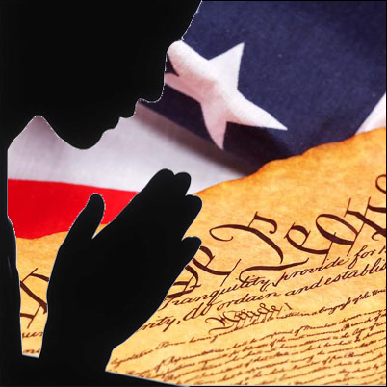

2020 Election Day Prayer
Lord God, as the election approaches,
we seek to better understand the issues and concerns that confront our city/state/country, and how the Gospel compels us to respond as faithful citizens in our community.
We ask for eyes that are free from blindness
so that we might see each other as brothers and sisters,
one and equal in dignity, especially those who are victims of abuse and violence, deceit and poverty.
We ask for ears that will hear the cries of children unborn and those abandoned,
Men and women oppressed because of race or creed, religion or gender.
We ask for minds and hearts that are open to hearing the voice of leaders who will bring us closer to your Kingdom.
We pray for discernment
so that we may choose leaders who hear your Word,
live your love, and keep in the ways of your truth
as they follow in your footsteps and guide us to your Kingdom of justice and peace.
Amen.

Leader: For the people of the United States, that we may be united in the common purpose of building a society in which everyone can live with dignity and hope, we pray to the Lord. . . .
All: guide us to your Kingdom of justice and peace.
For the Church, that we may be a witness to Christ's love by practicing charity and promoting justice and peace throughout the world, we pray to the Lord. . . .
All: guide us to your Kingdom of justice and peace
For Catholics throughout our nation, that the values of our faith may guide us as we exercise our responsibility as voters, we pray to the Lord. . .
All: guide us to your Kingdom of justice and peace .
For the members of this community, that we may find ways to help build a world of greater respect for human life and human dignity, we pray to the Lord. . . .
All: guide us to your Kingdom of justice and peace
For those who serve in elected office, that they may lead with courage and wisdom, reflecting the teaching that the moral test of our society is how the poor, the weak, and the vulnerable are faring, we pray to the Lord. . . .
All: guide us to your Kingdom of justice and peace
For all citizens of the United States, that our participation in the upcoming election may lead to a new millennium of greater justice and peace, we pray to the Lord. . . .
All: guide us to your Kingdom of justice and peace
For those who are suffering from poverty and injustice, that our decisions this election year may lead to policies and programs that help them build better lives, we pray to the Lord. . . .
All: guide us to your Kingdom of justice and peace
For parishioners who have been elected to public office, that they might use their offices to protect the unborn and enhance the lives of the poor and vulnerable, we pray to the Lord. . . .
All: guide us to your Kingdom of justice and peace
For the earth, that our nation's leaders will be inspired by God's Spirit to protect all of His creation, we pray to the Lord. . .
All: guide us to your Kingdom of justice and peace.
For workers around the world, especially children who work long hours for little pay, that we might all seek ways to promote fairness, justice, and dignity in their lives, we pray to the Lord. .
All: guide us to your Kingdom of justice and peace . .
For leaders around world, that they might find ways to bring an end to war and violence, and promote peace and development for all nations, we pray to the Lord. . .
All: guide us to your Kingdom of justice and peace.

Let us pray.
Gracious and loving God, let your Spirit be with us today. Hear our prayers, and increase in us the will to be your followers. Help us to draw on the resources of our faith as we use the opportunities of our democracy to shape a society more respectful of the life, dignity, and rights of the human person, especially the poor and vulnerable. Amen

