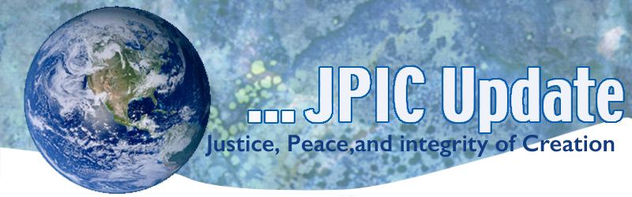
February 10, 2020
“If we accept and acquiesce in the face of discrimination, we accept the responsibility ourselves and allow those responsible to salve their conscience by believing that they have our acceptance and concurrence. We should, therefore, protest openly everything… that smacks of discrimination or slander.”
—Mary McLeod Bethune

February
Black History Month
Feb. 11 International Day for Women and Girls in Science
Feb. 11 World Day of the Sick
Feb. 14 Anniversary of Stoneman Douglas High School shooting
Feb. 14 Valentine’s Day
Feb. 19 Presidents Day
Feb. 20 World Day of Social Justice
Feb. 26 Ash Wednesday

*****************
TAKING ACTION
Be a voice for the voiceless
*********************

Real Story of Rosa Parks – (How are you challenged by this video?)
Black history taught in US schools is often watered-down, riddled with inaccuracies and stripped of its context and rich, full-bodied historical figures. Equipped with the real story of Rosa Parks, professor David Ikard highlights how making the realities of race more benign and digestible harms us all -- and emphasizes the power and importance of historical accuracy.
Watch now »

The NO BAN Act
The NO BAN Act is legislation that would terminate the administration’s refugee, Muslim, and asylum bans and ensure that no one is banned from our country based on religious or nationality-based discrimination. Join us in calling on all Members of Congress to cosponsor and pass the NO BAN Act (S.1123 / H.R.2214) – and to do everything in their power to oppose and stop the new expansion of the Muslim Ban.
CLICK HERE TO CALL YOUR SENATORS & REPRESENTATIVE TODAY!
Sample Script: “I’m your constituent from [CITY/TOWN], and [as a person of faith], I urge you to strongly oppose the cruel and harmful expansion of the Muslim ban that the Trump administration announced today, which will restrict entry to the United States from six new countries. I also urge you to cosponsor the NO BAN Act (S.1123 / H.R.2214), which would ensure that no one is banned from our country based on religious or nationality-based discrimination. My community is still feeling the negative impacts of this administration’s immoral and wrongful bans that continue to tear apart families. No one should be blocked from entering the country just because of their faith tradition or where they come from. My community welcomes refugees, asylum seekers, and immigrants, and I urge you to do the same.”
CLICK HERE TO CALL YOUR SENATORS & REPRESENTATIVE TODAY!

New Videos for Prayer and Action as Faithful Citizens
At their November General Assembly, the full body of bishops approved scripts for videos to inspire prayer and action in political life and to help Catholics apply the teachings of Pope Francis to our day. The videos complement Forming Consciences for Faithful Citizenship, the bishops’ teaching document for the faithful on the political responsibility of Catholics, and they seek to help the faithful participate in public life, prioritize faith over partisan politics, engage with civility, and respond to pressing issues of our day. Each video ends with a prayer.
The videos are available on the USCCB’s YouTube channel and at FaithfulCitizenship.org in four languages (English, Spanish, Tagalog, and Vietnamese):

***************************
INFORMATION/RESOURCES
***************************
Myth: The black unemployment rate is at an all-time low, and that means the economy is “working great” for all black workers.
Reality: Too many black workers are still out of work—black workers are twice as likely to be unemployed as white workers.

Adidas has announced a new wave of sustainability commitments for 2020.
The clothing brand has revealed that in 2020, for the first time, more than half of the polyester used in adidas products will come from recycled plastic waste.

To strengthen their commitment to sustainability, from 2024 onwards, adidas will use only recycled polyester in every product and on every application where a solution exists.
In 2020, Adidas also plans to produce a record 15 to 20 million pairs of shoes with plastic waste collected from beaches and coastal regions. Last year, Adidas already produced more than eleven million pairs of such shoes.

Over the last decade, Adidas has committed to a sustainable future. In 2016, the brand eliminated plastic bags from its stores. Since 2018, they have been sourcing 100 percent sustainably produced cotton, mainly from the Better Cotton Initiative.

What if Poor People were Part of the Planning?
Almost a billion people worldwide live in informal communities and slums, often without basic infrastructure like clean water, toilets or adequate roads. Urban planner Smruti Jukur Johari breaks down myths about these communities and shares examples of simple, common-sense solutions that arise when governments and architects work together with the residents -- instead of around them.
Watch now »

**************
Words to Ponder
***************
Truth is powerful and it prevails."
—Sojourner Truth

"It is my wish that the spiritual power of peace will touch the mind of every person on this earth, radiating out from a deep peace within our own minds, across political and religious barriers, across the barriers of ego and conceptual righteousness. Our first work as peacemakers is to clear our minds of mental conflicts caused by ignorance, anger, grasping, jealousy, and pride."
—Chagdud Tulku, The Path of Compassion

"Fighting, cheating, and bullying have trapped us in our present situation; now we need training in new practices to find a way out. It may seem impractical and idealistic, but we have no alternative to compassion, recognizing human value and the oneness of humanity."
—The Dalai Lama, The Way to a Meaningful Life

"The world's leaders have no idea what is for their own benefit. . . . Those who love others will be loved in return. Do good to others and others will do good to you. Hate people and be hated by them. Hurt them and they will hurt you. What is hard about that?" —Mo Tzu

