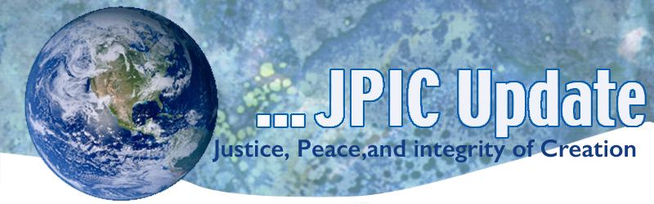
January 13, 2020

"The real question is why are we, together, creating a world that none of us as individuals would ever choose? Nobody gets up and says, 'How can I heat the planet today?' But what is it that isn't encouraging us to participate in the creation of the world we do want?"
—Frances Moore Lappe

January
Slavery and Human Trafficking Prevention Month
Catholic Poverty Awareness Month
Jan.16 National religious Freedom Day
Jan. 18 Walk for Life
Jan. 18 Women’s March
Jan, 20 Martin Luther King, Jr. Day
Jan, 27 International Day of Commutation in Memory of the Victims of the Holocaust

*****************
TAKING ACTION
Be a voice for the voiceless
*********************
Support the NIAC (National Iranian American Council)
It has been a long and hard week for our community with the anxieties of a looming war, feeling vulnerable at home, a tragic plane crash, and threats to our cultural heritage at the hands of our President. In such times of distress, we are reminded of the importance of unity and community. NIAC has been working around the clock to ensure that the concerns of our community and our voices are heard.

That’s why we are protecting our heritage by saying #HandsOffPersepolis. Iran is home to a culture and civilization that spans 2500+ years and hosts many of the world’s great cultural sites. Senator Ed Markey has introduced an important resolution (S.Con.Res 32) to protect Iran’s historical sites in response to Trump’s threats against them and to uphold our commitment to international law. Add your voice in support of this measure here to encourage your Senators to sign on.

Support the Arctic Reserve
The administration is seeking to overturn the plan’s protections by opening millions of acres in and around Teshekpuk Lake to oil and gas development. This reckless effort to sell off additional areas of the Western Arctic Reserve to fossil fuel companies is being done without regard for the harm it will likely cause to this ecologically sensitive area, the people who live there, and our climate.
The Western Arctic Reserve is the largest tract of wild and undisturbed public land in the U.S., providing vital habitat for hundreds of species, including migratory birds, brown bears, caribou, threatened polar bears, walruses, and beluga whales. Alaska Native communities across this region have sustained themselves for thousands of years with wild foods harvested from the Western Arctic Reserve’s lands and waters.
TAKE ACTION
***************************
INFORMATION/RESOURCES
***************************
Targeting El Paso
How did El Paso, Texas, come to be a testing ground for some of America’s most divisive immigration policies? FRONTLINE investigates in “Targeting El Paso.” It begins with the mass shooting and then address the immigration issues and policies affecting El Paso.
https://to.pbs.org/2ZMuDgI

What is next for the Middle East
Escalating U.S.-Iran tensions will reverberate throughout the Middle East—especially in Iraq. USIP’s Sarhang Hamasaeed and Dr. Elie Abouaoun explain what this means for Iraq and the region.
Read the Q&A

UN chief calls for international dialogue, cooperation
United Nations Secretary-General Antonio Guterres is urging all world leaders to de-escalate tensions, exercise restraint and revive international cooperation, noting that geopolitical tensions around the globe are at the highest seen in a century. "This cauldron of tensions is leading more and more countries to take unpredicted decisions with unpredictable consequences and a profound risk of miscalculation," Guterres says.

Australian Wild fires-A Suggestion from Notional Geographic
As travelers—especially those of us who have marveled at the beauty of Australia—it's good to ask what we can do to help. Our partners at ABC News have suggested donating to Australian Red Cross' Disaster Relief and Recovery or to WIRES, an organization committed to wildlife in Australia; or you can donate to local fire brigades. To support people affected by the fires, Fast Company suggests donating to the Salvation Army’s disaster appeal or the bushfire appeal fund set up by the St. Vincent de Paul Society. The fires have made Australia's declining koala population even more vulnerable; consider a donation to the Port Macquarie Koala Hospital, which rescues koalas in regions across New South Wales.

**************
Words to Ponder
***************
What is power after all? Every one of the power elite's overwhelming advantages depends on people obeying orders. This obedience depends on the legitimacy of the system. This legitimacy is a matter of collective perception, and we have the power to change people's perception."
—Charles Eisenstein

"There is no substitute for action. And what rich countries are doing, they are creating an illusion of action by just talking. When we demand action, they offer reports. When we demand money, they offer workshops. That is not going to help people who are suffering right now."
—Harjeet Singh

"The climate crisis has already been solved. We already have all the facts and solutions. All we have to do is to wake up and change. And why should I be studying for a future that soon will be no more when no one is doing anything whatsoever to save that future? And what is the point of learning facts in the school system when the most important facts given by the finest science of that same school system clearly means nothing to our politicians and our society?"
—Greta Thunberg

"Technologically, the scientists have helped to reduce disease, to improve communication, but also they are increasing the devastating power of the weapons of war, the power to murder vast numbers of people with one blow. The scientists are not going to save mankind, nor are the politicians . . . the crisis is not a matter of economics, of war, the bomb, the politicians, the scientists; the crisis is within us, the crisis is in our consciousness."
—Jiddu Krishnamurti

