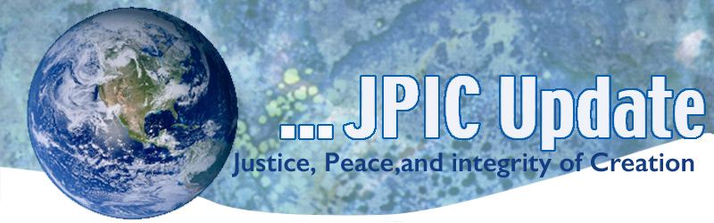
January 20, 2020
All are caught in the inescapable network of mutuality, tied in a single garment of destiny. Whatever affects one directly affects all indirectly. I can never be what I ought to be, until you are what you ought to be and you can never be what you ought to be until I am what I ought to be.
Martin Luther King, Jr.

January
Slavery and Human Trafficking Prevention Month
Catholic Poverty Awareness Month
Jan. 20 Martin Luther King, Jr. Day
Jan. 27 International Day of Commutation in Memory of the Victims of the Holocaust

*****************
TAKING ACTION
Be a voice for the voiceless
*********************

For those living in Los Angeles –Homeless Count
Homelessness is the moral and humanitarian crisis of our time, but sometimes it can be hard to know how to get involved and be a part of the solution so that people living on our streets can come indoors and get back on their feet.
This week, there is one simple way you can make a difference: volunteer for the annual Homeless Count.

Save the EPA
Just days ago, the Trump administration proposed changing how it implements the National Environmental Policy Act (NEPA), one of our nation's foundational environmental laws.
I'm asking you to speak out to oppose these changes, which could reduce important protections for nature and communities. Sign the petition to the White House now.

Refugee Resettlement
Please urge your members of Congress to support and cosponsor the GRACE Act (S. 1088/H.R. 2146) The GRACE act will restore refugee resettlement to its historic average of 95,000 individuals per year. Currently, the Administration has set refugee resettlement at 18,000 individuals annually, the smallest number of refugees yet. Given that there are more than 25 million refugees worldwide — more than half of whom are children — the dismantling of the resettlement program will keep thousands of vulnerable people from receiving the necessary aid, care, and protection that they deserve.
Click the link below to log in and send your message:
https://www.votervoice.net/BroadcastLinks/sYLl7PSYwsUcP0LJlJuXFw

***************************
INFORMATION/RESOURCES
***************************
Puerto Rico
Catholic Charities USA continues to support our brothers and sisters in Puerto Rico through prayer, donations, and technical support. If you would like to contribute to those impacted by the earthquakes you can donate here.

ICE National Detention Standards
ICE officially released its revisions to the National Detention Standards on Dec. 19, 2019, which are now available online at https://www.ice.gov/detention-standards/2019. These detention standards, which govern the treatment of immigrant detainees held in almost 140 facilities in 44 states, will apply to approximately 20 percent of ICE detainees nationwide.

The ACLU has prepared analysis summarizing ICE’s changes to the standards, which is available here: https://www.aclu.org/news/immigrants-rights/the-trump-administration-weakens-standards-for-ice-detention-facilities/. The new 2019 NDS weakens critical protections and oversight requirements for medical and mental health care, use of force, solitary confinement, detainee safety, legal access, and visitation, among others. The new NDS also incorporates some protections regarding sexual assault, disability access, language access, and telephone access, which are already required under federal law or outlined in settlement agreements.

UN removes voting rights of 7 states for being in arrears on dues
The United Nations stripped Lebanon, Yemen, Venezuela, Central African Republic, Gambia, Lesotho and Tonga of their voting rights at the UN General Assembly on Saturday for falling at least two years' behind in their UN dues payments. India, Armenia, Portugal and Ukraine are the only members to have paid their 2020 dues on time and in full.

The Israeli-Palestinian Conflict in 2020: What are the Possible Paths Ahead?
Despite tremendous efforts to resolve the Israeli-Palestinian conflict through a two-state solution, peace has been elusive. USIP’s Ambassador Hesham Youssef examines the potential scenarios facing Israelis, Palestinians, and the region as the stalemated conflict continues without progress toward peace.

Read the analysis

**************
Words to Ponder
***************

"Be kind. If you do nothing else, bring kindness to the forefront of your daily life. Our lack of respect for one another holds us back not only from working together for change but also from creating a civil society that embraces complexity and diversity."
—Rivera Sun, The Dandelion Insurrection

"We must strive to be moved by a generosity of spirit that will enable us to outgrow the hatred and conflicts of the past. . . . Resentment is like drinking poison and then hoping it will kill your enemies."
—Nelson Mandela

When the dark is at rest, the light begins to move."
—Taoist Wisdom

