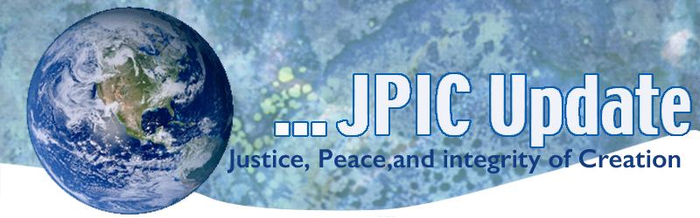
January 27, 2020
"I don't believe that nonviolence is something you can arrive at rationally. We can develop it as a spirituality and can obtain the grace necessary to practice it, but not as a result of reason. . . . We are called upon to be supernatural. We reach that way of being, not as a result of nature, but of prayer." —Miguel D'Escoto
January
Slavery and Human Trafficking Prevention Month
Catholic Poverty Awareness Month
Jan. 21-29 9 Days for Life
Jan. 27 International Day of Commutation in Memory of the Victims of the Holocaust
Jan. 29 National Day of Prayer to Save Asylum
February
Black History Month
Feb. 1-7 World day of Harmony Week

*****************
TAKING ACTION
Be a voice for the voiceless
*********************

Faith leaders and organizations invite you to join us on January 29
The U.S. government has dismantled the asylum system and put vulnerable people in danger.
Faith leaders and organizations invite you to join us on January 29 in #Faith4Asylum, a national day of prayer and action. This date marks one year since the first migrant was “returned” to Mexico under the inhumane “Remain in Mexico” policy.

We will be holding prayer vigils across the United States, calling for an end to U.S. government policies that harm asylum-seekers and reject their sacred humanity.
Sign up to host or attend a prayer vigil here!
#Faith4Asylum is a project of the Interfaith Immigration Coalition (IIC). The January 29 prayer vigils are just the first in an ongoing series of actions to #SaveAsylum.

Remain in Mexica Policy-one year old
The one-year anniversary of the "Remain in Mexico" policy is next week. The US government is denying an estimated 60,000 people access to due process, safety, and community support under this policy. Urge your Members of Congress to end the "Remain in Mexico" policy.

Puerto Rico Earthquakes
Puerto Rico continues to recover from a series of earthquakes earlier this month. Catholic Charities USA continues to support our brothers and sisters in Puerto Rico through prayer, donations, and technical support. If you would like to contribute to those impacted by the earthquakes, you can donate here.

Incarcerated Pregnant Women
California's legacy of unjust mass incarceration has a particularly devastating impact on the health and well-being of pregnant people in the state’s custody. Fair and just access to health care is a human right that cannot be infringed by a person's incarceration status. Yet, accessing adequate reproductive and pregnancy care is too often a frightening and traumatic experience for people incarcerated by the state.

Pregnant people who are incarcerated often receive biased, coercive information about their reproductive options, get substandard prenatal and postnatal care that endangers their health, and are denied reasonable accommodations that help ensure a safe and healthy pregnancy. Just recently, a woman in a California jail gave birth in isolation without any medical or personal support because of the state's failure to provide adequate health care.
Take Action

What microbes reveal about the ocean
When the ocean changes, the planet changes -- and it all starts with microbes, says biological oceanographer Angelicque White. Backed by decades of data, White shares how scientists use these ancient microorganisms as a crucial barometer of ocean health -- and how we might rejuvenate them as marine temperatures steadily rise.
Watch now »

***************************
INFORMATION/RESOURCES
***************************
Invisible Labor
If you: do laundry, are (or have been) pregnant, tidy up, shop for your household -- or do similar labor -- then by GDP standards, you're unproductive. In this visionary talk, economist Marilyn Waring seeks to correct the failures of this narrow-minded system, detailing why we deserve a better way to measure growth that values not just our own livelihood but the planet's as well.
Watch now »

UN: World must be ready for millions displaced by climate change
The global community must take steps to prepare for the millions of people who will be driven from their homes by climate-related disasters, United Nations High Commissioner for Refugees Filippo Grandi told World Economic Forum attendees this week. A UN Human Rights Committee on Tuesday ruled that refugees leaving their home country because of the effects of climate change may have the right to seek asylum.

Report highlights gender discrimination affecting poor girls
One in three girls from homes in the poorest 20% of the global population has never been to school, a problem exacerbated by gender discrimination and the focus of public funding on education for wealthier students, a UNICEF report shows. "If we invest wisely and equitably in children's education, we have the best possible chance of lifting children out of poverty by empowering them with the skills they need to access opportunities, and create new ones for themselves," says UNICEF executive director Henrietta Fore.

Displaced Person vulnerable to radicalization
A perception shared broadly both inside and outside Afghanistan is that displaced persons are vulnerable to radicalization. This Peaceworks report examines the relationship between displacement and radicalization and offers recommendations for more effective policies and programs.
Read the report

**************
Words to Ponder
***************
"I have never met any human being in all my travels—and I have traveled extensively, including time spent with Native American peoples, with Australian Aborigines, and with the Maoris of New Zealand—that gave me the slightest doubt that in our heart of hearts we are all one. Not just similar—one; there is only one human heart."
—David Steindl-Rast, Timeless Visions, Healing Voices

"They caused the first wound, but you are causing the rest; this is what not forgiving does. They got it started, but you keep it going. Forgive and let go, or it will eat you alive. You think they made you feel this way, but when you won't forgive, you are the one inflicting pain on yourself."
—Bryant McGill

