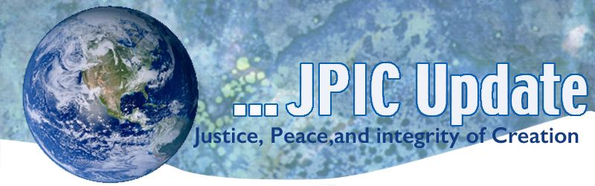
January 6, 2020

“The superfluous wealth of rich countries should be placed at the service of poor nations. The rule, which up to now held good for the benefit of those nearest to us, must today be applied to all the needy of this world. Besides, the rich will be the first to benefit as a result. Otherwise their continued greed will certainly call down upon them the judgment of God and the wrath of the poor, with consequences no one can foretell.”
The Catholic Bishops of the World at the Second Vatican Council
January
Slavery and Human Trafficking Prevention Month
Catholic Poverty Awareness Month
Jan, 5-11 National Migration Week
Jan. 11 National Human Trafficking Awareness Day
Jan. 11 Freedom Walk
Jan.16 National religious Freedom Day
Jan. 18 Walk for Life
Jan. 18 Women’s March
Jan, 20 Martin Luther King, Jr. Day

*****************
TAKING ACTION
Be a voice for the voiceless
*********************

Speak out for Peace
News that the United States has unilaterally assassinated IRGC Quds Force Commander Qassem Soleimani without Congressional approval—a profoundly reckless move that could have deadly consequences and result in a war with Iran.

Senator Tim Kaine has introduced a privileged resolution in the Senate, and Representatives Barbara Lee and Ilhan Omar have introduced it in the House, to force a vote on ending U.S. war on Iran. Click here to email your Senators and Representative.

Injunction against Executive Order 13888
On Wednesday, January 8th - the District Court in Greenbelt, Maryland will hear oral arguments about this anti-refugee executive order and consider a preliminary injunction to block its implementation. On September 26, the President Trump issued an Executive Order (EO 13888) that could drastically reduce, if not entirely end, the resettlement of refugees in your community. It requires state and local officials to provide written consent in order for refugee resettlement to continue in their states and localities.

LCWR is one of many faith-based organizations supporting the injunction against the Trump administration’s EO. This could decide the fate of the refugee resettlement program and impact thousands of refugees and their families. We’ve created a Toolkit for Action: Support Court Intervention to Save the Refugee Resettlement Program—which contains background information about the EO and the court case, talking points, sample letters-to-the-editor and opinion pieces, sample social media posts, and an action alert that you can share with your folks. Call Congress: Click here to call your 2 Senators and 1 Representative (Alternatively, you can call 202-858-1581 three times to be connected with your 1 Representative and 2 Senator.) See attached script for the call.

Ask your U.S. Senator to Support S. 874, the Dream Act of 2019
From November 2019 until Spring 2020, while the U.S. Supreme Court deliberates, it is vital that we encourage Congress to act to provide DACA recipients with a path to citizenship. As the House passed H.R. 6 which includes a path to citizenship for DACA recipients, we ask that you turn your attention to your Senators and urge them to stand in support of young adult immigrants by supporting legislative protection for DACA recipients generally and the Dream Act of 2019, S. 874, specifically.

U.S Postal Service at Risk
Did you know that the U.S. Postal Service is the most popular federal agency? USPS provides critical services to the American public, but now it is at risk of privatization. If we don’t all act soon, USPS could be privatized.
Tell the U.S. Postal Service Board of Governors: Don’t privatize the Postal Service

***************************
INFORMATION/RESOURCES
***************************
UNSC members alarmed as Iran vows retribution for general's killing
Members of the United Nations Security Council have voiced concern that the death of Iranian General Qassem Soleimani through a US airstrike and the country's promise to retaliate against the US will increase instability and tension in the Middle East. Some allies of the US asserted Iran bore some responsibility due to provoking the attack.

The United States Institute of Peace top 5 analysis and Commentary
From the conflict in Kashmir to the Afghan peace process, our experts provided in-depth, timely analysis on a host of critical topics.
- The Latest Kashmir Conflict Explained
- Afghanistan Talks: No Women, No Peace
- How Women Are Using Technology to Advance Gender Equality and Peace
- How Civil Society Can Help Prevent Violence and Extremism
- Understanding Libya’s South Eight Years After Qaddafi
Catholic Poverty Awareness Month
Income inequality in the U.S. is at its highest level in more than 50 years. U.S. Census Bureau

US Real Weekly Wages by Population
1979 2015
Bottom 10%: $414 $397
Median: $762 $832
Top 10%: $1,479 $2,004 US Bureau of Labor Statistics

US Average Household Incomes in 2015
Bottom 90% $34,074
Top 10% $312,536
Top 5% $477,293
Top 1% $1,363,977
Top 0.1% $6,747,439 University of California at Berkeley

66% of poor children in related families live with an adult who works and nearly 33% live with a family member who works full time year round. The Urban Institute
For more on Poverty, click here.
**************
Words to Ponder
***************
"Much violence is based on the illusion that life is a property to be defended and not a gift to be shared." —Henri Nouwen

"The Sufis tell a story of the Holy One who said to his disciples, ‘What’s better, do you think? Is it contemplation, or is it action?’ . . . They said, ‘Why, Holy One, it’s action, of course. What good is contemplation in a suffering world?’ And the Sufi said, ‘Ah, yes, but what good is action that proceeds from an unenlightened heart?’" —Sufi Wisdom

"O Great Spirit, whose breath gives life to the world and whose voice is heard in the soft breeze, we need your strength and wisdom. May we walk in beauty. May our eyes ever behold the red and purple sunset. Make us wise so that we may understand what you have taught us. Help us learn the lessons you have hidden in every leaf and rock. Make us always ready to come to you with clean hands and straight eyes, so when life fades, as the fading sunset, our spirits may come to you without shame." —From a Native American Prayer

