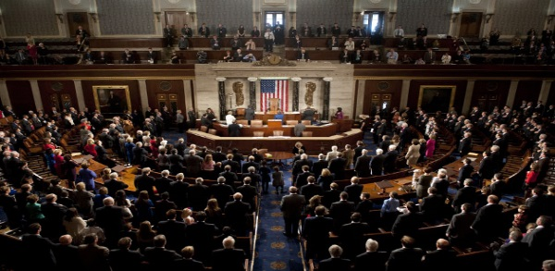
Blessed be the politician who personally exemplifies credibility.
Blessed be the politician who works for the common good and not his or her own interest. Blessed be the politician who remains consistent.
Blessed be the politician who works for unity.
Blessed be the politician who works to accomplish radical change.
Blessed be the politician who is capable of listening.
Blessed be the politician who is without fear.
Pope Francis’ “Beatitudes of the Politician”

Prayer for Congress
"Sovereign God, author of liberty, we gather in this historic chamber for the solemn responsibility of these impeachment proceedings. Give wisdom to the distinguished Chief Justice John Roberts as he presides. Lord, you are all powerful and know our thoughts before we form them,"
"As our lawmakers have become jurors, remind them of your admonition in 1 Corinthians 10:31 -- that whatever they do should be done for your glory. Help them remember that patriots reside on both sides of the aisle, that words have consequences and that how something is said can be as important as what is said. Give them a civility built upon integrity that brings consistency in their beliefs and actions. We pray in your powerful name, amen."
(Prayer from Senate Chaplain Barry Black)

Intercessions:
For those who serve in an elected office that they may lead with courage and wisdom, reflecting the Church's teaching that the moral test of our society is how the poor, the weak, and the vulnerable are faring, for this we pray.
Response: Hear our prayer.

For Catholics who have been elected to public office, especially senators who are facing difficult decisions at this time in history. May they use their position, as elected officials to seek the truth, to be persons of integrity, and make the right decisions that benefit our country, for this we pray.
Response: Hear our prayer.
Let us pray in thanksgiving for Nancy Pelosi, Adam Schiff and all those legislators who are persons of veracity and courage, seeking the truth that upholds democracy, for this we pray.
Response: Hear our prayer.
Together: We ask, Creator that You would give our leaders wisdom, insight and courage to lead us in ways that are just and righteous. We pray that they will not bow to political pressures, regardless of where that pressure originates, but instead that they would be courageous and mindful of the responsibilities entrusted to them. In Your mercy, God, hear our prayers.
We lift up the people of this nation, O God, and ask that You would give us discernment to know right from wrong and to act on it. We pray that You would give us courage to hear, and to see, and to listen to those who may have a different opinion than our own. We pray that You would infuse us with Your Spirit that we might be light in the midst of the darkness of this hour. Whatever the outcome of the impeachment vote in the Senate, help us to find ways to be healers, unifiers and reconcilers, which is who You have called us to be. In Your mercy, O God, hear our prayers. (Adapted from the National Council of Churches)

Prayer for President Trump
‘Let us pray for that miraculous moment, when God's grace can reach President Trump. Nothing is beyond God, this I believe, and Jesus' reliance on prayer has to be ours. No one is outside the reach of love and so we pray, and will continue to pray for this man to recognize the devastatingly harm he is doing to others and to himself, to his own image of God.’
So we pray:
May President Trump seek the ways of righteousness, justice and mercy. Grant that he may be enabled by the inspiration of God’s Spirit to lead our country with honesty and integrity.

May he be open to work with others to find solutions to difficult problems. We ask that you, Creator, guide him to speak respectfully and with humility. Help him to show Christ-like love to those with whom he interacts and with whom he may not agree.
May he work with other nations for peaceful solutions to complex problems and be an advocate for all people of the United States and those of other nations.
May he care for people in need, especially the most vulnerable and those surrounded by global poverty. May he have compassion on immigrants and refuges.
May he listen to and accept the validity of the scientists regarding climate change and initiate legislation to address ways to heal the earth.
We know all things are possible with God. Amen

Paraphrased from Nancy Pelosi

