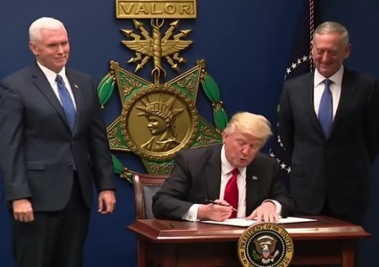
Blessed be the politician who personally exemplifies credibility.
Blessed be the politician who works for the common good and not his or her own interest. Blessed be the politician who remains consistent.
Blessed be the politician who works for unity.
Blessed be the politician who works to accomplish radical change.
Blessed be the politician who is capable of listening.
Blessed be the politician who is without fear.
Pope Francis’ “Beatitudes of the Politician”

Prayer for President Trump
Let us pray for that miraculous moment, when God's grace can reach President Trump. Nothing is beyond God, this I believe, and Jesus' reliance on prayer has to be ours. No one is outside the reach of love and so we pray, and will continue to pray for this man to recognize the devastatingly harm he is doing to others and to himself, to his own image of God.
So we pray:
May President Trump seek the ways of righteousness, justice and mercy. Grant that he may be enabled by the inspiration of God’s Spirit to lead our country with honesty and integrity.

May he be open to work with others to find solutions to difficult problems. We ask that you, Creator, guide him to speak respectfully and with humility. Help him to show Christ-like love to those with whom he interacts and with whom he may not agree.
May he work with other nations for peaceful solutions to complex problems and be an advocate for all people of the United States and those of other nations.
May he care for people in need, especially the most vulnerable and those surrounded by global poverty. May he have compassion on immigrants and refuges.
May he listen to and accept the validity of the scientists regarding climate change and initiate legislation to address ways to heal the earth.
We know all things are possible with God. Amen

Paraphrased from Nancy Pelosi

