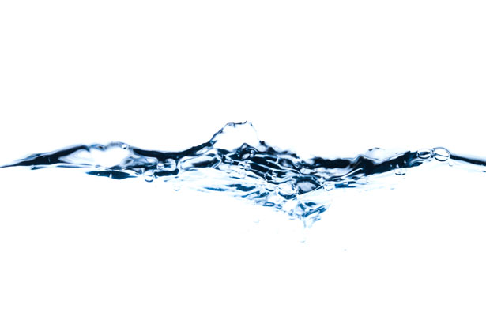
Living Water

At the very dawn of creation, the Creator breathed on the waters, making them holy. The waters of Baptism births one into a new life. A developing baby protected and nurtured by water for nine months in a mother’s womb. Water is essential to life. Our bodies contain about 60 % of water.
Hmong people bath in water on the first day of their New Year to cleanse away anything bad that happened the in the past year to begin anew.
Dr. Masaru Emoto, a Japanese scientist revolutionized the idea that our thoughts and intentions affect the physical realm. As one of the most important water researchers in the world, he studied the scientific evidence of how the molecular structure in water transforms when exposed to human words, thoughts, sounds and intentions.
Native peoples believe that water is living and holds memories. In a recent TED talk, Kelsey Leonard, from the Shinnecock Nations, speaks of the importance of viewing water. She states that one might understand the sacredness of water if one asked, “Who is water?” The same way you might ask, “Who is your Grandmother?
We are in a global water crisis. Kelsey addresses the need to grant personhood to water providing it with protections and rights. The Whanganui River in New Zealand and the Ganges River in India were both granted legal personhood. Recently Toledo granted the legal personality of Lake Erie. In California, the Yurok tribe granted legal personhood to the Klamath River.
Fill a bowl of clean water. Take time and put aside your busyness, fear and blindness. Breathe positive and loving thoughts into the water. Ask the water to fill you with visions of how you can be channels of living water for a world thirsting for healing, justice, peace and love.

Created by Sr. Diane Smith, CSJ

