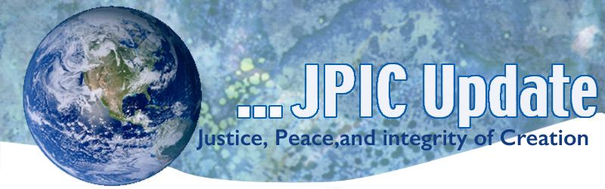
March 16, 2020
However, I would not like this pain, this very strong epidemic make us forget the poor Syrians that are suffering at the border between Greece and Turkey: a people suffering for years. They must flee from war, from hunger, from sicknesses. Let us not forget our brothers and sisters, the many children that are suffering there.”
Pope Francis

March
Women’s History Month
March 19 Feast of St. Joseph
March 21 International Day for the Elimination of Racial Discrimination
March 21 International Day of Forest
March 22 World Water Day
March 24 Anniversary of Oscar Romero’s death

*****************
TAKING ACTION
Be a voice for the voiceless
*********************

Protect DACA Recipients
The House of Representatives successfully passed the American Dream and Promise Act of 2019 (H.R. 6) last June, which would provide dreamers, TPS holders, and DED holders a pathway to citizenship. It is time for the Senate to pass a clean Dream Act immediately to give over 800,000 DACA recipients and eligible undocumented youth a pathway to citizenship.

To take action and protect DACA Recipients:
Please sign this petition by tomorrow, March 17th.

Access the “Faith4DACA: Facing the Future Together!” Lenten toolkit here.

Click here for more information on the #HomeisHere campaign led by DACA leaders.

This Election Season, Pledge Civility, Clarity, Compassion through ‘Civilize It’
Civilize It campaign by taking the pledge below as a way to promote civility, love our neighbors, and build community. Civilize It is about making room in your heart for those with whom you disagree. Civilize It is a non-partisan call to focus on the dignity of all people, even when we disagree, and to put faith in action by bearing witness to a better way forward. Take the pledge. Anyone and everyone can commit together to honoring human dignity through civil conversation. Go to: https://www.wearesaltandlight.org/civilize-it

Share this reflection with your faith community as a bulletin insert or handout.
Learn more about conscience formation.
Pray this Prayer for Civility with your family or community.
Use this examination of conscience to reflect on your own commitment to civility.

2020 Census
The USCCB continues to urge all people, regardless of citizenship to participate in the 2020 Census. We have created the following resources to answer these questions and urge you to read them and encourage others to do the same.
Backgrounder on Federal Information Sharing and Census 2020 EN
Backgrounder on Federal Information Sharing and Census 2020 SP
Backgrounder on State Information Sharing and Census 2020

***************************
INFORMATION/RESOURCES
***************************
IOM: Number of Mediterranean migrant deaths hits 20K
A mass drowning last month brought the total number of migrants who have died attempting a Mediterranean crossing to more than 20,000, the International Organization for Migration reports. "The fact that we have reached this grim new milestone reinforces IOM's position that there is an urgent need for increased, comprehensive (search and rescue) capacity in the Mediterranean," says Frank Laczko, director of IOM's Global Migration Data Analysis Center.

**************
Words to Ponder
***************
"There is a need we all feel to be part of something larger than ourselves. So much of our energy as human beings goes into finding that connection with something larger. We have a deep need for identity. Belonging to something larger is a way of telling ourselves, ‘This is who I am.’ It is a quest that never quite gets answered."
—David Spangler, The Call

"The task is clear: to create a culture of caretaking in which no one and nowhere is thrown away, in which the inherent value of people and all life is foundational."
—Naomi Klein

"How do we change the world? Change the story."
—Charles Eisenstein

