April 20, 2020

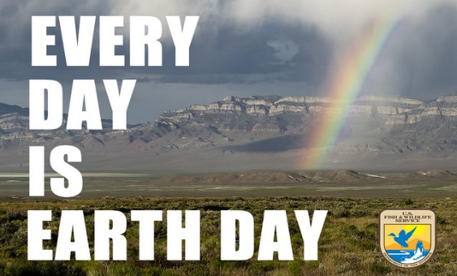

April
Women’s Black History Month
National Donate Life Month
April 22 Earth Day
April 23 Ramadan begins
April 24 Arbor Day
April 28 Anniversary of Chernobyl Disaster

Taking Action
(Be a voice for the voiceless)

Earth Day April 22
Wednesday is Earth Day. Please take time to pray and reflect on the prayer attached to this week’s JPIC UPDATE email. Take time to sit in nature and appreciate its beauty. How may you be a voice for the earth?

Census
If you have not filled out the census, please do so. Remind all with whom you interact to fill out the census. This count has legislative consequences in terms of representation in Congress .It also determines the amount of federal funding each state and county can access.

Save a Tree
The recent surge of TP demand has put our forests in danger. I just signed this petition to ask retailers and suppliers to make more recycled fiber TP instead of cutting down critical forests for virgin fiber.

Join me and take action to protect the forests. https://act.stand.earth/page/18118/petition/1?ea.tracking.id=em-share&sp_ref=629549228.424.205490.e.0.2&source=email

Information/Reflection

How You Can Help Save the Monarch butterfly and the Planet
Monarch butterflies are dying at an alarming rate around the world -- a looming extinction that could also put human life at risk. But we have just the thing to help save these insects, says author Mary Ellen Hannibal: citizen scientists. Learn how these grassroots volunteers are playing a crucial role in measuring and rescuing the monarch's dwindling population -- and how you could join their ranks to help protect nature. (You'll be in good company: Charles Darwin was a citizen scientist!)
Watch now »

Help for undocumented in California
On April 15, Gov. Gavin Newsom thanked the state’s undocumented workers, many of whom pick fruits and vegetables, care for the sick and perform other critical jobs.

Then he announced a plan to help them: The federal coronavirus relief package does not include aid for undocumented immigrants. So Mr. Newsom said the state would step in with $75 million, plus another $50 million from philanthropic organizations, to be paid to affected families who are undocumented.
He said it was the first such move in the nation.

Racism Affects the Economy
Racism makes our economy worse -- and not just in ways that harm people of color, says public policy expert Heather C. McGhee. From her research and travels across the US, McGhee shares startling insights into how racism fuels bad policymaking and drains our economic potential -- and offers a crucial rethink on what we can do to create a more prosperous nation for all. "Our fates are linked," she says. "It costs us so much to remain divided."
Watch now »

While Americans continue to grapple with the coronavirus crisis, an estimated 131,300 Temporary Protected Status (TPS) holders from El Salvador, Honduras, and Haiti are helping to support the nation by serving as essential workers.
Notably:
- The average TPS holder from El Salvador, Honduras, and Haiti has lived in the United States for 22 years.
- An estimated 11,600 health care workers today are TPS holders, including:
- 8,100 home health and personal care aides, nursing assistants, orderlies, and psychiatric aides
- 1,900 health technologists and technicians
- 1,300 other health care support occupations
- Across the entire country, the 76,100 TPS holders working in food-related occupations or industries—from grocery stores and restaurants to farms and food processing plants—have felt the impacts of COVID-19.

Words to Ponder

Quotes from Laudato Si’:

What kind of world do we want to leave to those who come after us, to children who are now growing up? (#160)

There is a growing sensitivity to the environment and the need to protect nature, along with a growing concern, both genuine and distressing, for what is happening to our planet… Our goal is not to amass information or to satisfy curiosity, but rather to become painfully aware, to dare to turn what is happening to the world into our own personal suffering and thus to discover what each of us can do about it. (#19)

If we approach nature and the environment without…openness to awe and wonder, if we no longer speak the language of fraternity and beauty in our relationship with the world, our attitude will be that of masters, consumers, ruthless exploiters, unable to set limits on their immediate needs. By contrast, if we feel intimately united with all that exists, then sobriety and care will well up spontaneously. (#11)

There is a growing sensitivity to the environment and the need to protect nature, along with a growing concern, both genuine and distressing, for what is happening to our planet… Our goal is not to amass information or to satisfy curiosity, but rather to become painfully aware, to dare to turn what is happening to the world into our own personal suffering and thus to discover what each of us can do about it. (#19)

We have to realize that a true ecological approach always becomes a social approach; it must integrate questions of justice in debates on the environment, so as to hear both the cry of the earth and the cry of the poor. (#49)

