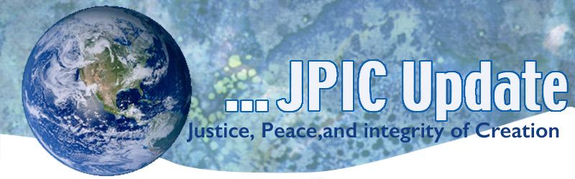
April 27, 2020
"That nothing is static or fixed, that all is fleeting and impermanent, is the first mark of existence. It is the ordinary state of affairs. Everything is in process. Everything—every tree, every blade of grass, all the animals, insects, human beings, buildings, the animate and the inanimate—is always changing, moment to moment. We don’t have to be mystics or physicists to know this. Yet at the level of personal experience, we resist this basic fact. It means that life isn’t always going to go our way. It means there’s loss as well as gain." —Pema Chodron

April
Women’s Black History Month
National Donate Life Month
April 28 Anniversary of Chernobyl Disaster
April 29 International Dance Day
May
Asian American Month
Pacific Islander Heritage Month
May 1 Feast of St. Joseph the Worker
May 5 Cinco de Mayo
May 7 National Day of Prayer
May 10 Mother’s Day
May 15 Endangered Species Day

Taking Action
(Be a voice for the voiceless)

An Ode to Living on Earth
If you had to explain to a newborn what it means to be a human being living on Earth in the 21st century, what would you say? Visual artist Oliver Jeffers put his answer in a letter to his son, sharing pearls of wisdom on existence and the diversity of life. He offers observations of the "beautiful, fragile drama of human civilization" in this poetic talk paired with his original illustrations and animations.
Watch now »
Planet of the Humans
Michael Moore presents Planet of the Humans, a documentary that dares to say what no one else will this Earth Day — that we are losing the battle to stop climate change on planet earth because we are following leaders who have taken us down the wrong road — selling out the green Click on the link below to watch the film.
Michael Moore Presents: Planet of the Humans | Full ...

Information/Reflection

Wisdom of John Muir
A five minute video worth watching.
https://youtu.be/0khHxSVwZVA

How to shift your mind set and choose the future
When it comes to big life problems, we often stand at a crossroads: either believe we're powerless against great change, or we rise to meet the challenge. In an urgent call to action, political strategist Tom Rivett-Carnac makes the case for adopting a mindset of "stubborn optimism" to confront climate change -- or whatever crisis may come our way -- and sustain the action needed to build a regenerative future. As he puts it: "Stubborn optimism can fill our lives with meaning and purpose."
Watch now »

Words to Ponder

"Some changes look negative on the surface but you will soon realize that space is being created in your life for something new to emerge."
—Eckhart Tolle
"No matter how difficult and painful it may be, nothing sounds as good to the soul as the truth."
—Martha Beck

"At the end of life, the wish to be forgiven is ultimately the chief desire of almost every human being. In refusing to wait, in extending forgiveness to others now, we begin the long journey of becoming the person who will be large enough, able enough, and generous enough to receive at the end that absolution ourselves."
—David Whyte

"The highest benchmark of love, courtesy, generosity and beauty that is put into the world will never vanish from the world. And when it’s time, it will restore itself instantly."
—Cynthia Bourgeault

