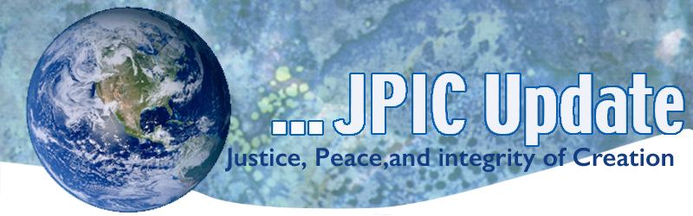
May 11, 2020
"You do not need to know precisely what is happening or exactly where it is all going. What you need is to recognize the possibility and challenges offered by the present moment, and to embrace them with courage, faith, and hope."
—Thomas Merton

May
Asian American Month
Pacific Islander Heritage Month
May 12 International Nurses Day
May 14-24 Laudato Si’ Week
May 15 Endangered Species Day
May 21 Cultural Diversity Day for Dialogue and Development
May 24 Anniversary of Laudato Si’
May 25 Memorial Day

Taking Action
(Be a voice for the voiceless)

Celebrate “Laudato Si’ May 16-24 with Prayer and Action
The theme of Laudato Si’ Week is “everything is connected.” In his video message, Pope Francis asked Catholics to think about the future of our common home.
What kind of world do we want to leave to those who will come after us, to children who are growing up? Motivated by this question, I would like to invite you to participate in Laudato Si' Week from 16-24 May 2020. It is a global campaign on the occasion of the fifth anniversary of the encyclical letter Laudato Si' on the care of the common home. I renew my urgent call to respond to the ecological crisis, the cry of the Earth and the cry of the poor cannot continue. Let's take care of creation, a gift of our good Creator God. Let's celebrate Laudato Si' Week together. May God bless you and do not forget to pray for me."

Our national partner, the Catholic Climate Covenant, is also offering resources you can use during the week of prayer and action. Their virtual webinar-based program, “Earth Day at 50/Laudato Si’ at 5: An Urgent Appeal for Action” is available for download. It is a free, one-hour educational program that includes prayers, readings, a short video, discussion questions, and suggested actions.

Protecting Nature
As Congress starts back in session, they're rightly focused on COVID-19, people's safety, and our economy. We must be sure they know that boosting the economy and protecting nature isn't an either-or-choice – in fact, nature is an important part of the solution for our recovery.
Investing in nature, public lands and clean energy have a track record of creating jobs and directly strengthening local economies. And, economy-boosting measures should sustain environmental protections that contribute to community health.
Let's make our voices heard together. Please send a message to your lawmakers urging them to include nature in solutions for spurring our economy.

Oppose Annexation Of West Bank
This action alert is from Churches for Middle East Peace (CMEP), a coalition of which the Maryknoll Office for Global Concerns is a member.

Last week Secretary of State Mike Pompeo said the decision to annex much of the West Bank was Israel’s to make. With the announcement of an emergency national unity government, bringing together Prime Minister Netanyahu and his former chief rival, Benny Gantz, Israel is likely to proceed with an annexation vote as early as July 1. Annexation would have a devastating impact on the ground for Palestinians - taking away any realistic opportunity for a Palestinian state and a just resolution to the conflict.
Take action: Let your Members of Congress know you oppose annexation.

Protect Wetlands, Wildlife and Water
The president's "Nuclear Fuel Working Group" has issued recommendations to dramatically expand uranium mining by lifting protections on public lands like those around the Grand Canyon. The group is also calling to slash environmental laws and use our precious tax dollars to prop up the deadly industry.
Tell federal officials to drop this dangerous plan and protect our wildlands, water, wildlife and communities from deadly uranium pollution.

Information/Reflection

UN Chief: None of us is safe Until all of us are safe
A massive, cooperative public health effort is required to overcome the coronavirus pandemic, says United Nations Secretary-General Antonio Guterres, noting that the interconnected nature of today's society means the virus will spread from countries lacking resources to handle it. The World Health Organization is urging leaders to identify early cases of the disease that were misdiagnosed to provide a clearer picture of the outbreak to the global health community.

"Flatten the Curve of Violent Conflict” is a new, very brief video (a bit over 1 minute long) focused on changing the metaphor of addressing COVID-19 from “war” to “nonviolent mobilization,” made by the Raven Foundation. It includes an interview with my friend and colleague, Ken Butigan.

You can see the page in which the video is embedded here: https://www.ravenfoundation.org/flatten-the-curve-of-violent-conflict/.

Here is the video by itself: https://www.dropbox.com/s/dbnvm89la33c8b5/FlattenTheCurve_Final.mp4?dl=0.

Words to Ponder

"We need to mainstream Nonviolence in the Church, we need to move it from the margins of Catholic thought to the Center. Nonviolence is a spirituality, a lifestyle, a program of societal action and a Universal Ethic."
—Bishop Robert McElroy, "Path of Nonviolence: Towards a Culture of Peace"

"Faith does not need to push the river because faith is able to trust there is a river. The river is flowing. We are in it."
—Richard Rohr

"O Divine Spirit, do You see me here? May your starry hands shower grace upon me-the strength to keep remembering You and the sorrow to keep calling You, my only refuge and comfort. Blissful, oh beautiful is your Divine World! Lift me to your world of a million twinkling stars!"
—Amma, the Hugging Saint

"You live in the illusion of appearance of things.
There is a reality but you do not remember this
You are nothing and in being nothing
you are everything.
That is all."
—Kalu Rinpoche

