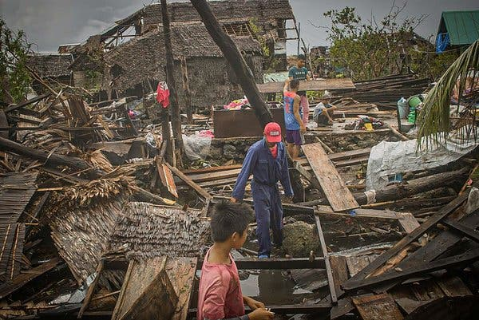

Prayer for those affected by Typoon Vongfong
From the New York Times-Tens of thousands of people fled to evacuation centers on Friday as the first typhoon to hit the Philippines this season barreled toward the main island of Luzon, dumping torrential rains and raising fears that the coronavirus could spread in crowded shelters.

Good and gracious God we pray for the thousands that have been affected by Typoon Vongfong on the Island of Luzon. In this time of great need we plead for your mercy for those who are suffering its disastrous effects.

Let us pray in intercession:

For those who have lost loved ones,
we pray that they may be comforted and be given hope

For those who have been injured,
we pray that they may be comforted and be given hope

For those who have lost their homes,
we pray that they may be comforted and be given hope

For those who have lost their crops,
we pray that they may be comforted and be given hope

For those who have lost their fishing boats,
we pray that they may be comforted and be given hope

For those in fear of contracting the coronavirus while in shelters,
we pray that they may be comforted and be given hope
Creator, help us to help them, to know what to do and to have the compassion, fortitude and creativity to do it. Move us to respond now to the urgent needs that cannot wait. Steady us to be there in the future as the victims of this disaster rebuild. Give us the grace of generosity—in our prayers and our contributions.
We are all brothers and sisters: we are the work of your hands. Receive the dead into your love. Comfort the survivors with the power and protection of your peace. May we love as you love, and may we all find peace in this tumultuous world. Our help is in the name of the good and gracious God, who made heaven and earth.
AMEN.

(Adapted from Catholic Health Association’s Prayer for the Philippines Disaster Victims during Typhoon Haiyan)

