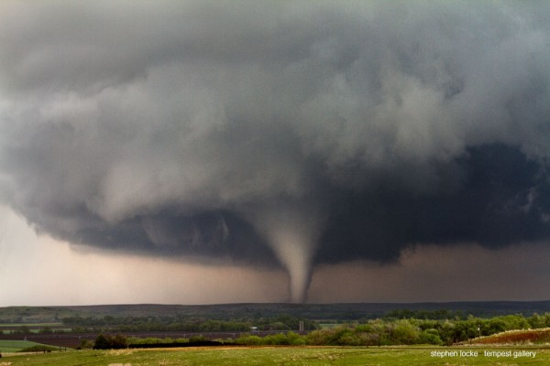

For Victims of Natural Disasters
Gracious God, I pray for the victims of this disaster, Lord that you would comfort the lives that were spared Creator, and that you would take care of those who perished.
Creator, please bless those who are doing everything they can to help these people and make sure that things run smoothly in repairing this great community/State/Nation.
Please help the victims to have patience and help family members to be reunited. Lord, I pray that you will ensure that the victims do not come under any illnesses from this disaster, and I pray that they get enough food and clean water and proper shelter for everyone.
Creator, please touch the hearts of the world to continue to pray for these people and to donate whatever they can to help rebuild this wonderful State.
Creator, only you can make miracles happen and I am asking for one now. Amen.
- Bridgett of Ontario, CA, adapted from "Hurricane Katrina Prayer"

