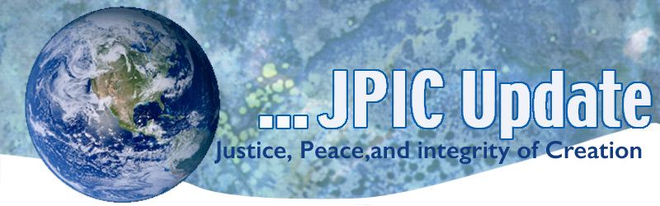
July 13, 2020
"Our lives are all that belongs to us. So, it is how we use our lives that determines what kind of persons we are. . . . I am convinced that the truest act of courage, the strongest act of humanity is to sacrifice ourselves for others in a totally nonviolent struggle for justice."
—Cesar Chavez

July
Black Family Month
HIV Awareness Month
National Parks Month
July 14 Kateri Tekakwitha
July 14 Bastille Day
July 18 Nelson Mandela Day
July 30 World Day Against Trafficking of Persons
August
August 6 Bombing of Hiroshima
August 9 Bombing of Nagasaki

Taking Action
(Be a voice for the voiceless)

A Virtual Rally
Join our virtual rally July 14th to amplify our messaging and urge senators to advance a #FaithfulRecovery. If you’re not on social media, you can email your senator on July 14th.
Simply create a sign about what a #FaithfulRecovery looks like to you, take a photo and post it on social media. Everything you need to participate can be found here, including signs you can print out and personalize as well as sample Facebook, Twitter and Instagram posts.
We’ll be emphasizing the need to address environmental injustices that make communities of color more at risk for respiratory diseases like covid-19, as well as the need to invest in clean energy jobs to get people back to work, to build resilience for future crises such as climate change, and to provide assistance to poor countries struggling even more at this time.
Prepare to be a Faithful Voter
To help voters prepare for the 2020 U.S. elections, the Maryknoll Office for Global Concerns is offering a series of webinars in which we will dive deeper into the key global issues featured in our series of two-page global issue briefs, Faithful Voting and Global Concerns.
The next webinar, "Sanctions: Nonviolent Tool or Lethal Weapon?" will be held on Wednesday, July 15 from 12:30-1:00 pm EDT. Click here to register.

2020 is a critical year for our democracy
We know that every voice matters and every vote counts. We cannot allow our policies to keep people from voting or being counted, especially when those methods of undercounting and voter suppression disproportionately impact communities of color and low income families. People should be able to exercise their constitutional right to vote and stay healthy, even during a pandemic.
RSVP to join us for this live conversation on July 15, 2020 from 3:00 - 4:00 PM Eastern.

World Day against Human Trafficking
July 30 is the World Day against Trafficking in Persons. Please join the Coalition of Catholic Organizations against Human Trafficking (CCOAHT) U.S. Catholic Sisters Against Human Trafficking (USCSAHT) in our month-long campaign to draw attention to human trafficking and to protect our children.

Information/Reflection

November 3 Election Day
In less than four months, we will again be voting on the presidential election as well as on other congressional, state and local office. The media will bombard the nation with political ads. In the words of Colin Powell:
“You are not just voting for an individual,
you are voting for an agenda.
You are voting for a political philosophy.”

Women in Asia disproportionately affected by the pandemic.
A study by the United Nations Women's Regional Office for Asia and the Pacific found that women in the region are being disproportionately affected by the pandemic. Women are more likely to lose hours at work, experience higher levels of stress and have less health insurance than men on average, the study found. Full Story: ThePrint (India) (7/6)

Words to Ponder

"When you reach real ability you will be able to become one with the enemy. Entering his heart you will see that he is not your enemy after all." —Tsuji
"My Lord God, I have no idea where I am going. I do not see the road ahead of me. I cannot know for certain where it will end. Nor do I really know myself, and the fact that I think that I am following your will does not mean that I am actually doing so. But I believe that the desire to please you does in fact please you. And I hope I have that desire in all that I am doing. I hope that I will never do anything apart from that desire. And I know that if I do this you will lead me by the right road, though I may know nothing about it. Therefore will I trust you always, though I may seem to be lost and in the shadow of death. I will not fear, for you are ever with me, and you will never leave me to face my perils alone."
---Thomas Merton

"I’m very conscious of the fact that you can’t do it alone. It’s teamwork. When you do it alone you run the risk that when you are no longer there nobody else will do it."
—Wangari Maatha

