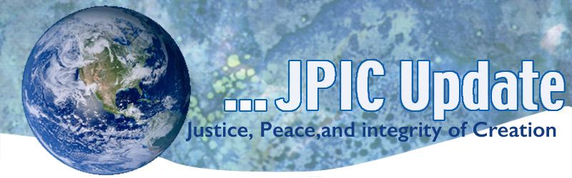
July 6, 2020
"One of the reasons we're destroying the planet is that it has lost its sacred dimension for us. The planet as given to us by science is a physical reality essentially meaningless in itself. It's a resource for our physical activity."
—Thomas Berry, Dream of the Earth

July
Black Family Month
HIV Awareness Month
National Parks Month
July 6 Dali Lama Birthday
July 14 Kateri Tekakwitha
July 14 Bastille Day
July 30 World Day Against Trafficking of Persons

Taking Action
(Be a voice for the voiceless)

Take the pledge to protect others
This Pledge started as a way of clearly and unequivocally standing against the racism of anti-lockdown protests, threats of violence, the erosion of common human decency at every level, and the absence of calls to consider the common good. It's also a simple, straightforward way to open up conversations in your families and among friends to discuss how to make decisions and act with integrity and respect.
Read more about the Pledge and sign it today by clicking here.

Save Nevada’s Desert
Desert National Wildlife Refuge is the largest refuge in the lower 48 and home to a wide range of rare and threatened species, including bighorn sheep and desert tortoises. But now this Nevada treasure is at risk of being dismantled by the Democratic-led House of Representatives.
In a stunning betrayal of public lands, House Armed Services Committee Chairman Adam Smith of Washington state included a disastrous provision authored by public-lands enemy Rep. Rob Bishop of Utah in the National Defense Authorization Act.

Now Democrats on the committee have greenlighted giving 850,000 acres of the Desert Refuge to the Air Force for use as an industrial training center. This massive land grab will allow some of the most pristine habitat in the West to be bombed and destroyed in war games. And it'll set a devastating precedent for giveaways of our national wildlife refuge system.
Join us in demanding that Chairman Smith and the Democrats reverse this massive giveaway to the military and stand up for the desert refuge and its precious wildlife.
Take Action

Information/Reflection

Through the eyes of a black artist
An artwork's color or composition can pull you in -- and put you on the path to having important and difficult conversations, says artist Titus Kaphar. In this stunning talk, he reflects on his artistic evolution and takes us on a tour of his career -- from "The Jerome Project," which draws on religious icons to examine the US criminal justice system, to "From a Tropical Space," a haunting body of work that centers around Black mothers whose children have disappeared. Kaphar also shares the idea behind NXTHVN, an arts incubator and community for young people in his hometown.
Watch now »

US, Russia, China face off over Sanctions on Iran
The US is advancing a United Nations Security Council resolution that would see sanctions against Iran extended indefinitely, a move opposed by Russia and China, who say the US should not have exited the 2015 nuclear deal with Iran. UN Under-Secretary-General for Political and Peacebuilding Affairs Rosemary DiCarlo says the 2015 deal is critical to regional peace and stability. Full Story: Reuters

Saharan Dust Storm Posses health threat to Caribbean
An unusually intense and widespread dust storm blanketing the Caribbean is contaminating rainwater and air and could have significant health effects, the World Meteorological Organization says. "The ongoing dust storm, which has affected daily life in the Caribbean, shows the importance of forecast and warning services," says WMO Atmospheric Environment Research Division chief Dr. Oksana Tarasova.
Full Story: The Jamaica Observer

Words to Ponder

Another of the major strengths of the nonviolent weapon is its strange power to transform and transmute the individuals who subordinate themselves to its disciplines, investing them with a cause that is larger than themselves. They become, for the first time, somebody, and they have, for the first time, the courage to be free."
—Dr. Martin Luther King, Jr.

If there is to be a livable world for those who come after us, it will be because we have managed to make the transition from the Industrial Growth Society to a Life-Sustaining Society. . . . While the agricultural revolution took centuries and the Industrial revolution took generations, (the Great Turning) has to happen within a matter of years. It also has to be conscious—involving not only the political economy, but the habits, values and understandings that foster it."
—Joanna Macy

This thing we call nonviolence is the pearl of great price. Our job—and what an honor it is to be able to take it up—is to use it, to preserve it, and to pass it on. Picture a lit candle—providing an unfathomable, beautiful, and mysterious light of indescribable power. It dispels the darkest darkness, and yet, like most wonderful things, it is extremely modest and vulnerable."
—Chris Moore Backman

