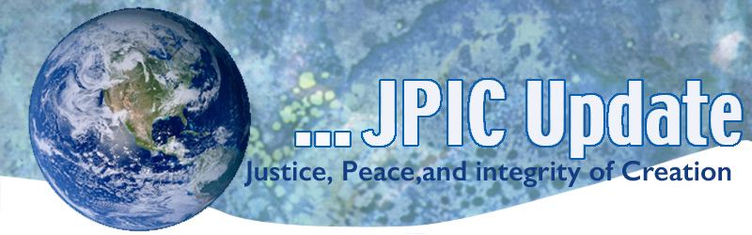
June 1, 2020
“For … those in positions of public trust, I have this message: Yours is the duty to bring about a peaceful change in America. If your response to these tragic events is only ‘business as usual’ — you invite not only disaster, but dishonor.” — President Lyndon Johnson, address to the nation, July 27, 1967
June
National Gun Awareness Month
Men’s Health Month
LGBT Pride Month
June 1 National Day of Mourning
June 1 World Reef Day
June 5 World Environment Day
June 8 World Ocean Day
June 14 Flag Day

Taking Action
(Be a voice for the voiceless)

Day of Lament
Today is declared a day of lament for those suffering from COVID-19
A moment of silence and prayer was observed at noon but it is not too late to reflect and pray with the resources provided:
Lament Resources from Sojourner
- We have created a video as a call to lament the more than 100,000 lives lost to COVID-19. We encourage you to watch and share this video. It is linked above, and it can also be found on this page.
- Prayer – God, we come to you in grief, mourning, and lament of the more than 100,000 people we have lost to COVID-19. Not only has this pandemic taken our brothers and sisters, it has also revealed many of the most unequal, broken pieces of our society. We ask that, as we move forward, you may work in and through us, so that we may continue to build your beloved community. Find more prayer resources here

Another reason for Lamenting
The week of May 24th will be remembered as a week of lament, mourning, grief, and outrage in the death of yet another Black person. Death has been a constant presence throughout the world as lives have been impacted by loss and pain. The most troubling aspect is the fact that so much of it is unwarranted. The simple fact is that people are dying needlessly due to the reality that the resources of this world are not equally nor equitably distributed. Our grief is compounded by the fact that there is intentionality in the suffering inflicted.

Please support National Black Led Organizations focused on this issue:
Movement for Black Lives: https://m4bl.org/
Color of Change https://colorofchange.org/
NAACP: https://www.naacp.org
National Action Network: https://nationalactionnetwork.net/

Tell Senators to Boost SNAP
The House of Representatives' HEROES Act provides a much-needed boost to SNAP (food stamps) and struggling families. But not everyone is on the same page about the need for a boost to SNAP—Senate Republican Leader Mitch McConnell and others have come straight out and said multiple times that they don’t want to boost SNAP in any way. MomsRising urges us to demand the Senate to boost nutrition assistance and SNAP in the next pandemic relief package. Go to: https://action.momsrising.org/sign/COVID19_SNAP/

Drop Border-Wall Lawsuit Against Catholic Orphanage
President Trump's border wall is now threatening a Catholic orphanage near the U.S.-Mexico border. The Department of Justice has filed an eminent-domain lawsuit against Sacred Heart Children's Home in Laredo, Texas, demanding access to the orphanage's land to conduct surveys for the wall. The Trump administration seems to be taking cruel advantage of the pandemic to speed up wall construction, since public demonstrations aren't possible during social distancing.

Under eminent domain laws, the government must pay landowners a fair price -- yet the administration only wants to give the sisters $100 to let its construction teams on their land. This orphanage has been run for more than 100 years by the Servants of the Sacred Heart of Jesus and of the Poor. Show the sisters that they are not alone, Demand that the DOJ drop this outrageous lawsuit. Go to: https://act.faithfulamerica.org/sign/border_orphanage

Information/Reflection

Black Voter Suppression
EPI economist Jhacova Williams, working on our Program on Race, Ethnicity, and the Economy (PREE), is developing groundbreaking research on how past racial atrocities continue to have lasting impacts today.

Williams has analyzed data on lynchings of blacks from 1882 to 1930—a time when there were more than 3,000 lynchings. And her research found a disturbing pattern: the more lynchings in a given county translates to lower black voter registration a century later.
Watch EPI’s video that details how lynchings were the original form of voter suppression, and then share this video on Facebook and Instagram.

World Reef Awareness Day
World Reef Awareness Day on June 1st serves as a call to action for consumers, businesses and organizations to reflect on the delicate ecosystem of our ocean’s coral reefs. The day brings together the general public, influencers and opinion leaders to create active change through education and engagement.

Coral reefs are living communities of colonial organisms made of individual polyps that excrete a bone-like skeleton. This skeleton forms large rock-like structures that are homes for thousands of organisms.

The health of a reef tells us a lot about the health of an ocean. Many fish and ocean animals rely on the protection of the healthy, living reef for spawning season. The reef also provides more than protection; it supplies a rich, thriving food chain, too. From plankton and algae to the largest sea creatures, the reef ecosystem is a significant life support system.

Words to Ponder

”You stand with the least likely to succeed until success is succeeded by something more valuable: kinship."
—Father Greg Boyle, SJ

My original enthusiasm for the new story, back in the day, was mainly because I felt then, as I feel now, that nonviolence needed a conceptual framework, and the new story offered one. Now I believe as well that the new story needs nonviolence as much as nonviolence needs the new story. When nonviolence and the new story complete themselves, they complete each other. Nonviolence is not only at home in the new story; nonviolence is the new story. And the way to get us there."
—Michael Nagler, The Third Harmony

"In 1989, thirteen nations comprising 1,695,000,000 people experienced nonviolent revolutions that succeeded beyond anyone's wildest expectations. . . . If we add all the countries touched by major nonviolent actions in our century (the Philippines, South Africa . . . the independence movement in India . . .), the figure reaches 3,337,400,000, a staggering 65% of humanity! All this in the teeth of the assertion, endlessly repeated, that nonviolence doesn't work in the 'real' world." —Walter Wink

