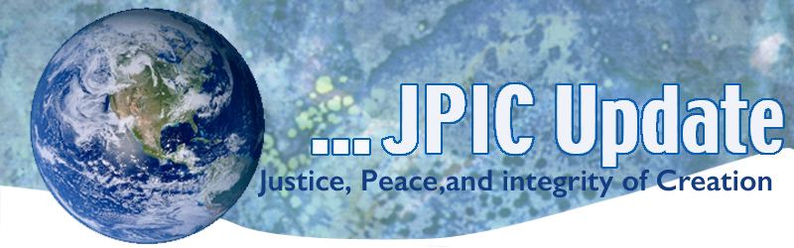
June 8. 2020
"It is my conviction that if we are neutral in situations of injustice, we have chosen the side of the oppressor."
—Archbishop Desmond Tutu

Taking Action
(Be a voice for the voiceless)

National Moment of Silence.
Join us Monday June 8th, two weeks after George Floyd’s death, for a Day of Fasting and Focus which will culminate at 5:00pm when we are asking people to stop where you are for 8 minutes and 46 seconds in silence in honor of the time George Floyd had the literal knee of the state on his neck.
Take the pledge to participate in a National Moment of Silence in Honor of George Floyd and other victims of police brutality on Monday at 5pm EST.

Whether in your homes, at work or in the streets, we are calling for people of conscience to stop wherever they are to join us for a live-streamed moment of silence, litany and a message of support for the uprisings across the country and a call for organizing a movement in this moment from Bishop William J. Barber, II, co-chair of the Poor People’s Campaign: A National Call for Moral Revival. You can tune in at fb.com/anewppc and click here for a litany you can read after the moment of silence.

The Assumptions of White Privilege and What We Can Do About It
Father Bryan Massingale, professor of theology at Fordham University, writes in the National Catholic Reporter: “The reason for the grief, outrage, lament, anger, pain and fury that have been pouring into our nation's streets [is] because folks are tired. Not only of the individual outrages. But of the fundamental assumption that ties them all together: that black lives don't matter and should not matter — at least not as much as white ones….To quote James Baldwin, facing the truth ‘would reveal more about America to Americans than Americans want to know.’ Or admit that they know…. The only reason for racism's persistence is that white people continue to benefit from it.” Read more: https://www.ncronline.org/news/opinion/assumptions-white-privilege-and-what-we-can-do-about-it

World Oceans Day
\When we think of public health risks, we may not think of the ocean. Increasingly, however, the health of the ocean is intimately tied to our health. Some may be surprised to read that organisms discovered at extreme depths are used to speed up the detection of COVID-19. With all probability, it is the environment that could give a solution to humankind.
This is one of the multiple reasons why we should celebrate World Oceans Day: to remind everyone of the major role the oceans have in everyday life. They are the lungs of our planet, providing most of the oxygen we breathe. The purpose of the Day is to inform the public of the impact of human actions on the ocean, develop a worldwide movement of citizens for the ocean, and mobilize and unite the world’s population on a project for the sustainable management of the world's oceans. They are a major source of food and medicine and a critical part of the biosphere. In the end, it is a day to celebrate together the beauty, the wealth and the promise of the ocean. (https://www.un.org/en/observances/oceans-day)
Urge President Trump to Rescind Border Proclamation
On May 15, President Trump announced that the closure of the U.S.-Mexico border, which began on March 20, will now continue indefinitely. The border closure denies asylum seekers their legal right to present their asylum claims to U.S. authorities. In addition, the Administration issued a proclamation on April 22 banning most immigrants from entering the United States.
Take action:

The United Nations refugee agency has stated that public health concern during the pandemic is not sufficient reason to forego the legal obligation to hear asylum claims.

In addition, the U.S. Bishops Conference released a statement expressing concern that the April 22 proclamation banning immigration will only separate families and will not help the economy.
Take action: Urge President Trump to rescind the proclamation banning immigration.

Information/Reflection

Hear Martin Luther King in “Riot is the Language of the Unheard”
https://www.youtube.com/watch?v=9ph5g0jb8cE&feature=youtu.be
Vatican Office Invites Church on Journey to 'Total Sustainability' In Next Decade
The Vatican's peace and justice office is inviting Catholic communities across the world to join a grassroots movement to gradually work toward "total sustainability" in the coming decade, a path that would include carbon neutrality, simpler lifestyles, and divestment from fossil fuels. The hope is by starting small, the movement will eventually reach a "critical mass" with more and more corners of the church taking part over time. Read more: https://www.ncronline.org/news/earthbeat/vatican-office-invites-church-journey-total-sustainability-next-decade

Deforestation around the World
he rate of deforestation around the world has decreased in the past five years, but approximately 22 million hectares of forest were lost between 2010 and 2020 -- an increase over previous decades, a report from the United Nations Environment Programme and the UN Food and Agriculture Organization shows. "Forests regulate global weather and provide livelihoods to millions of people - we just cannot afford to continue down this road," says UNEP executive director Inger Andersen

Words to Ponder

Nonviolent transformation requires of us the spiritual discipline of mindfulness, of attending all of experience and embracing the seeming opposites—death and life, sorrow and joy . . . I believe that this kind of steady attention has a cumulative effect on our consciousness."
—Mary Litell, The Transforming Power of Consciousness

"Inspiration is not garnered from the recitation of what is flawed; it resides, rather, in humanity's willingness to restore, redress, reform, rebuild, recover, reimagine and reconsider. 'Consider' (con sidere) means 'with the stars'; reconsider means to rejoin the movement of heaven and life."
—Paul Hawken

