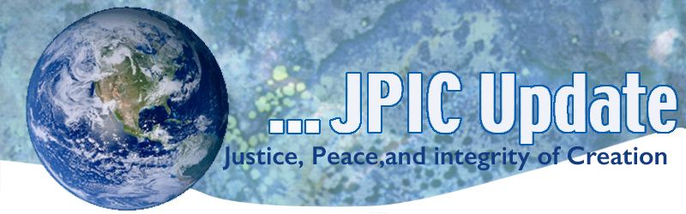
May 25, 2020
God and Gracious God,
Keep in your mercy those men and women
who have died in the cause of freedom
and bring them safely
into your kingdom of justice and peace.
May
Asian American Month
Pacific Islander Heritage Month
May 24, 2020-May 24, 21 Laudato Si’ Special Anniversary Year
May 24 Anniversary of Laudato Si’
May 25 Memorial Day
May 29 Pentecost
June
National Safety Month
Men’s Health Month
LGBT Pride Month
June 5 World Environment Day
June 8 World Ocean Day

Taking Action
(Be a voice for the voiceless)

Take Action on Behalf of the Planet
Coca-Cola, PepsiCo, and Nestlé were the top three sources of plastic pollution identified by volunteers who conducted over 484 cleanups in over 50 countries and 6 continents in September 2019 according to a new Break Free From Plastic report. Instead of taking steps to curb their pollution, these companies continue to focus on false solutions like improving recycling rates in our broken global recycling system.

If we don't change course now, scientists predict that there will be more plastic than fish in the oceans by 2050. Call on these three multinational corporations to stop using the single-use plastic packaging and to develop new delivery systems that focus on reusable materials. It only takes a minute: Click here: http://bit.ly/2JAsleb

Emergency Health Care Bill
Rep. Pramila Jayapal and Sen. Bernie Sanders have introduced the Health Care Emergency Guarantee Act to let Medicare step in to cover care for the tens of millions who are losing their employer-based health insurance during the pandemic. Sign here if that sounds good to you!

Support Jobs and Green Energy
Over 36 million Americans are newly unemployed. Some will be able to return to their jobs when the pandemic ends, but not everyone.

We need to create millions of new jobs repairing our country’s crumbling infrastructure. We must modernize the power grid, move toward renewable energies, and make homes, schools and businesses energy efficient. And we must replace lead pipes so that they stop poisoning our children.

Simply put, we must invest in workers, our planet, and our children’s future.
Add your voice: After the pandemic, let's rebuild our infrastructure so that we can put millions back to work and save our planet at the same time.

Protect Workers
These COVID-19 infections could have been reduced if science-based safety guidelines from the Centers for Disease Control and Prevention were enforced. However, current guidelines are voluntary and unenforceable, which leaves employers, such as Tyson, free to ignore them.
Urge your members of Congress to cosponsor and work to advance the COVID-19 Every Worker Protection Act to ensure science-based and enforceable protections are included for all workers on the front lines.

Information/Reflection

Remembering Memorial Day
This Memorial Day, take a moment to learn and share about the lives, quotes, and stories of fallen About Face: Veterans Against the War members in a special online memorial. Share stories about those that have inspired you and copy/paste this link on your social media so that others can be inspired as well: https://bit.ly/afvawmemorial.

Vatican Office Invites Church on Journey to ‘Total Sustainability’ in Next Decade
The Vatican's peace and justice office is inviting Catholic communities across the world to join a grassroots movement to gradually work toward "total sustainability" in the coming decade, a path that would include carbon neutrality, simpler lifestyles and divestment from fossil fuels. The news came on the first day of Laudato Si' Week, a Vatican-sponsored event running through May 24, the encyclical anniversary date. Now the week will kick off a full calendar of events through May 24, 2021.
As part of those plans, the dicastery outlined a multi-year "Laudato Si' Action Platform" that in gradual stages will invite Catholic dioceses, religious orders, schools and other institutions to publicly commit to a seven-year journey toward ecological conversion and "total sustainability." The hope is by starting small, the movement will eventually reach a "critical mass" with more and more corners of the church taking part over time. Read more: https://www.ncronline.org/news/earthbeat/vatican-office-invites-church-journey-total-sustainability-next-decade

Can Peace be Negotiate Online?
Digital tools are being quickly developed that could provide opportunities for peacebuilding unimaginable just a couple of years ago. USIP’s Juan Diaz-Prinz discusses how can we ensure that this development, now accelerated by the COVID-19 pandemic, remains viable in practice.
Read the blog

The Trump Administration Is Reversing Nearly 100 Environmental Rules. Here’s the Full List.
The Trump administration has dismantled more than 60 environmental rules and regulations, with an additional 34 rollbacks still in progress. Calling the rules burdensome to the fossil fuel industry and other businesses, the administration has weakened limits on carbon dioxide emissions and rolled back clean air and water rules, to name a few. The New York Times provides the full list. Read more: https://www.nytimes.com/interactive/2020/climate/trump-environment-rollbacks.html

Words to Ponder

"The best and most beautiful things in the world cannot be seen or even touched, they must be felt with the heart." —Helen Keller

The world is holy. We are holy. All life is holy. Daily prayers are delivered on the lips of breaking waves, the whisperings of grasses, the shimmering of leaves."
—Terry Tempest Williams

The more clearly we can focus our attention on the wonders and realities of the universe about us, the less taste we shall have for destruction." —Rachel Carson

