Kaia'tanó:ron
Kateri Tekakwitha

Lily of the Mohawks
1656-1680

Feast Day July 14

Special Prayers
KATERI TEKAKWITHA

Gah-deh-lee Deh-gah-quee-tah

LET US PRAY

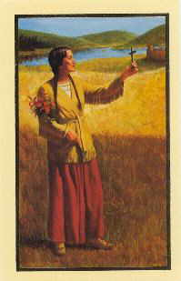
Click on graphic for enlarged view

Blessed Kateri, you are revered as the mystic of the American wilderness. Though orphaned at the age of four, and left with a scarred face and damaged eyesight from illness, you were esteemed among the Mohawk tribe. When you asked to be baptized a Christian, you subjected yourself to abuse by your people and were forced to run away. You endured many trials but still flowered in prayer and holiness, dedicating yourself totally to Christ. I ask you to be my spiritual guide along my journey through life. Through your intercession, I pray that I may always be loyal to my faith in all things. Amen.

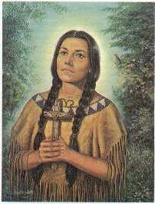
Click on graphic for enlarged view

Loving creator God, we acknowledge your power and presence in the Four Directions of your vast and beautiful universe. We celebrate Kateri Tekakwitha, "Lily of the Mohawks", as one of your Son's most faithful followers. Help us to turn our backs on all evil and walk in her footsteps, sharing our love and Christian concern with others. Let us reverence, as she did, your mystical presence in the poor and suffering.

Through Kateri's powerful intercession, we confidently ask you to grant us this special favor we ask for in her name. (Mention your intentions.) Share your healing and peace especially with my family, friends and the sick, whom we commend to your loving care. We ask this through your crucified and risen Son, our Lord Jesus Christ, the eternal World, who lives and reigns with you forever and ever. Amen. Prayer from the National Shrine in Fonda (Caughnawaga) NY

Click on graphic for enlarged view

I said a prayer for you today at the birthplace of Kateri Tekakwitha in Auriesville, New York. I said a prayer for you today and I know God must have heard. I felt the answer in my heart although He spoke no word. I didn't ask for wealth or fame. I knew you wouldn't mind. I asked Him to send treasures of a far more lasting kind. I asked that He'd be near you at the start of each new day; to grant you health and blessings and friends to share your way. I asked for happiness for you in all things great and small, but it was for His loving care I prayed for most of all.

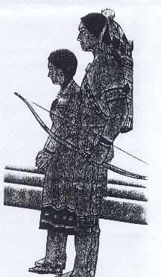
O Great Spirit, whose voice I hear in the winds, and whose breath gives life to all the world, hear me! I am small and weak. I need your strenth and wisdom.
Let Me Walk In Beauty, and make my eyes ever behold the red and purple sunset.
Make My Hands respect the things you have made and my ears sharp to hear your voice.
Make Me Wise so that I may understand the things you have taught my people.
Let Me Learn the lessons you have hidden in every leaf and rock.
I Seek Strength, not to be greater than my brother, but to fight my greatest enemy -- myself.
Make Me Always Ready to come to you with clean hands and straight eyes.
So When Life Fades, as the fading sunset, my spirit may come to you without shame.
Princess Pale Moon, Ambassador of Friendship

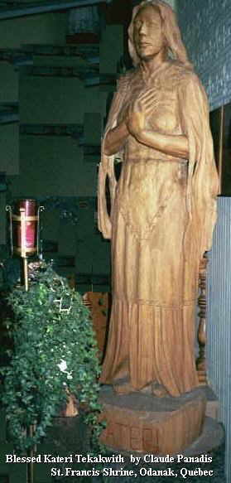
Great Spirit, our Creator, hear us while we offer the united voice and devotion of your people in thanksgiving.
For the sun that warms our earth-house filling it with all good things.
For sleep that rides with the moon and stars; the rivers that flow from the mountains of living water. For healing herbs, fruits, nuts, grains, fish and meats. For the Spirit of the hunt when the great chiefs smoke the pipe of peace.
Keep us, the children of nature, tall, erect, strong, brave and young. Teach us the patience of the turtle. Give us the vision of the eagle. Give our prophets wisdom.
Teach us to love our Mother Earth with her dawn, evening light, dark clouds, mists, trees, flowers, and the rains that come from the Thunderbird.
Make us humble before the great mystery and worthy of our ancient faith. When the fires die out, and the winds no longer blow, lead us down the beautiful trail to the camp of our fathers in the Happy Hunting Grounds ...
So may it be, Great Spirit,
So may it be.
Blessed Kateri,
Star of Native People and
Bright Light for all!
We thank God for your
heroic courage,
constant perseverance
and deep love of the Cross.
Pray for us
that our love for Christ may deepen.
And may we imitate you
in following God's Will
even when difficulties arise.
In Jesus' name, we pray.
Amen.

